Autumn 2016 DHA Newsletter
© Disability History Association

2 MESSAGE FROM THE EDITOR
Penny Richards

3 ANNOUNCEMENTS

7 CALLS FOR PAPERS

8 UPCOMING CONFERENCES

9 “Seeing Our History –
an outreach study of outdoor blind lives in Edwardian Scotland”
(Iain Hutchison}
MESSAGE FROM THE EDITOR
Penny L. Richards

WELCOME!

As I type this, I have just finished the challenge #100WikiDays—starting a new article for Wikipedia every day for 100 days. Of course there were disability history stories in the mix! Frances McCollin (1892-1960) and David Duffield Wood (1838-1910) were blind organists and composers based in Philadelphia. Clara J. Peck (1862-1926) started a tuberculosis hospital in Greensboro NC. Bonnie Ntshalintshali (1967-1999) and Wonderboy Nxumalo (1975-2008) were both South African artists with HIV. Margaret Horton Potter (1881-1911) was a Chicago novelist who was institutionalized for alcoholism and morphine addiction. Josie Wood (1874-1965) started the South African Library for the Blind lending service. —PLR

If you have a moment, would you contact DHA President Sandy Sufian at (sufians@uic.edu) and let DHA know if you have any suggestions for improvements, especially with regard to activities or programs? The DHA Board of Directors are striving to find new ways to promote disability history and would be very appreciative of your feedback.

Have you renewed your DHA membership for 2017? Please consider doing that right now, while you’re enjoying the newsletter, it won’t take but a moment. And if you already have your membership, perhaps make a surprise gift to a colleague or student?
http://dishist.org/?page_id=25

Did you know that the DHA is now on Facebook?
The Disability History Association recently set up a public Facebook page telling its social media audience about the organization and posting updates on scholarships, conferences, lectures and more. It has also set up a closed Facebook group for its members to join that will act as a way for DHA members to exchange their work, post queries, and give individual updates and announcements. For members, please search for Disability History Association in the facebook search bar and then request to join this group.
https://www.facebook.com/groups/disabilityhistoryassociation/ (closed group)
https://www.facebook.com/DisabilityHistory/

ANNOUNCEMENTS

Sara Scalenghe’s Disability History in the Ottoman Arab World, 1500-1800 wins the DHA Book Award
After careful consideration, and having received the most submissions to date, the DHA Publication Award Committee awarded the DHA Book Award to:

Sara Scalenghe, Disability in the Ottoman Arab World, 1500-1800 (New York: Cambridge University Press, 2014).

Congratulations Sara!

Comments from the committee:

“[Disability in the Ottoman Arab World, 1500-1800 is an] excellent contribution to disability history that helps open up a new and much needed non-Western (and preindustrial) perspective in the field. Beautifully written in clear and accessible prose, Scalenghe’s book is also a very enjoyable read.”

“Wonderful intervention on disability history: unique for its non-Western and pre-modern focus (as well as its points about “academic imperialism” in disability history)… Terrific examples and analysis of contingencies and ‘loopholes’ in Ottoman legal practices and categories.”

“…accessible and informative. [Disability in the Ottoman Arab World] continues the important work of globalizing disability studies; it opens up new possibilities for comparative approaches; and it challenges the category of disability itself.”

This coming year, DHA will be welcoming submissions for the Best Article Award. An announcement detailing the submission process is forthcoming.

Paul Longmore’s book wins Honorable Mention in 2016 DHA Book Awards

It is with great pleasure that the DHA announces that Paul Longmore, the father of our field, has received Honorable Mention for the 2016 Publication Award.

Thanks to Cathy Kudlick and a dedicated group of disability scholars for working on bringing this book to publication and for making sure that Paul’s legacy, scholarship and impact upon our field and its genesis, lives on.

About Telethons: Spectacle, Disability, and the Business of Charity. (New York: Oxford University Press, 2016), the prize committee remarked:

“[Telethons is a] superb study and a model of how to write disability history. Longmore’s book will surely be consulted by disability scholars and historians for years to come. Engagingly written and full of profound insights into a wide range of issues, it compellingly demonstrates the significance of disability to modern American culture.”

“… in-depth look at a common cultural phenomenon in America, impressive research and consideration of different factors (gender/social class, etc.), well-written and cited… [Longmore makes an] important intervention into the links between politics, the media, and private interests in constructing and presenting disability in modern U.S. discourse.”

Congratulations and deep felt gratitude to Paul for his monumental contributions to our field.

DHA Graduate Student Scholarship awarded to Haley Gienow-McConnell
Haley Gienow-McConnell is a doctoral candidate who specializes in disability history at York University in Toronto, Ontario. Haley was a featured speaker at Brock University’s (St. Catharines, Ontario) Department of History Speaker Series on October 28, 2016. Her presentation focused on the historical television representations of disability. Haley’s scholarship adds to foundational works on media and disability by shifting the focus from the “architects of disability images” to broader historical contexts and interlocking factors that shape stories, images, and audience understandings of disability representations. This includes close readings of historical, cultural, political, economic, and personal factors of television production. To illustrate this critical engagement, Haley spotlights "The Waltons,” a long-running and highly popular television drama series.

We congratulate Haley on her work and look forward to learning about the presentation in the next DHA newsletter.

History of Place: Our Guild, Disability history film to premiere
(from: http://historyof.place/premiere-of-our-guild-the-first-history-of-place-project-film/)

To mark the International Day for Disabled People and Disability History Month, Screen South is delighted to announce the launch of the first film produced as part of the groundbreaking disability project, History of Place, made possible by the Heritage Lottery Fund (HLF).

The film, which shares the little known history of one of Bristol’s historic buildings, The Guild of the Brave Poor Things, will be screened at M Shed, Bristol on Saturday 3rd December from 2pm – 3pm. There will be an opportunity to hear about the filmmaking process from those involved, including some of the young participants discussing the film. There will also be an introduction from Esther Fox, head of the Accentuate programme and speakers on this year’s Disability History Month’s theme: language.

Founded in 1894, Bristol’s Guild of the Brave Poor Things brought together disabled people from across Bristol for meetings, lectures, apprenticeships and holidays. As part of the History of Place project, volunteer researchers have been working in the local museums and archives, uncovering the lost stories of those who joined as members of the Guild. Volunteers have also been exploring the design and build of the groundbreaking Guild Heritage House in Old Market, Bristol. These stories were used to inspire a group of local young disabled people to make this short film which explores the significance of possibly the first purpose built building for disabled people in the country, the admissions process and attitudes to access.

Supported by the Heritage Lottery Fund, History of Place is a nationally significant social history programme, charting disabled people’s lives from the middle ages until the late 20th Century in relation to built heritage. The project will investigate and animate eight important built heritage sites, with the objective of elevating this history to greater prominence. History of Place is part of the Accentuate Programme, which provides life changing opportunities for deaf and disabled people to participate and lead in the cultural sector.

Disability and Industrial Society project wins Outstanding Contribution to the Arts and Culture Award
Research led by Professor David Turner at Swansea University has been recognised at the University’s annual Research and Innovation Awards. The project, Disability and Industrial Society: A Comparative Cultural History of British Coalfields 1780-1948, supported by a Wellcome History of Medicine Programme Grant, is a collaboration between academics at Swansea, Aberystwyth, Glasgow Caledonian and Strathclyde Universities. The project re-evaluates the experiences of disabled people in the Industrial Revolution through a study of those injured or impaired through chronic illness as a result of work in the coal industry.
The team was awarded a prize for their Outstanding Contribution to the Arts and Culture, sponsored by Parthian Books, for their exhibition, From Pithead to Sickbed and Beyond: the Buried History of Disability in the Coal Industry before the NHS. The exhibition, which examined the history of disabled mine workers and their experiences of rehabilitation and (in some cases) return to work, uncovered an aspect of the Welsh industrial past previously ignored in museum interpretations.
The exhibition was held at the National Waterfront Museum in Swansea between June and October 2015 and attracted 40,000 visitors, before moving to the National Library of Wales, where it ran until April 2016. A touring version of the exhibition has visited venues across the country.
Exhibition material has been used in the new Coal galleries at the National Waterfront Museum to ensure that disability is recognized permanently as part of Wales’s industrial past. Material from the exhibition on industrial disability has been used in an educational resource on coalmining aimed at primary (elementary) school pupils.
Eighty-eight per cent of visitors interviewed about the exhibition said that they had learned something new about coalmining and disability, and 74 per cent said that the exhibition had made them want to find out more about the history of disability or coalmining. The project team worked with Swansea Access for Everyone to ensure that the exhibit was accessible, and disabled people’s responses to the exhibit were captured in a series of podcasts.
Project leader Professor David Turner said, ‘The project team is delighted to have won this award. Public engagement has been an important part of our work on the project and we are pleased that the contribution of the exhibition to enriching public understanding of disability history has been recognized in this way’.

CALLS FOR PAPERS

CFP:
Histories of Healthy Aging
University of Groningen, 21-23 June 2017
The conference focuses especially (but not exclusively) on the pre-modern period. Submissions for 20-minute papers should include a 250-word abstract and short CV. Deadline is 1 December 2016. Subject to funding, travel grants might be available for junior researchers. This conference is part of the project Vital Matters and is sponsored by the Netherlands Organization for Scientific Research. For more information:
historiesofhealthyageing@gmail.com
www.vitalmatters.nl
CFP:
“Why is my pain perpetual?” (Jer 15:18): Chronic Pain in the Middle Ages
University College London, 29 September 2017
This conference seeks specifically to pay ‘historical attention’ to chronic pain in the medieval era. It will bring together researchers from across disciplines working on chronic pain, functioning as a collaborative space for medievalists to enter into much-needed conversations on this highly overlooked area of scholarship. Prof Esther Cohen (Hebrew University of Jerusalem), one of the foremost scholars on pain in the Middle Ages, will deliver the keynote address at the conference. If you’re interested in speaking at the conference, please submit an abstract of 250-300 words and a brief bio to the organiser, Alicia Spencer-Hall (a.spencer-hall [at] qmul.ac.uk), by 15 January 2017. For more information:
https://dishist.hypotheses.org/282

UPCOMING CONFERENCES

18 December 2016, Tel-Aviv, Israel
Symposium: Future Forms: The Body in Science Fiction
http://allevents.in/jaffa-tel%20aviv/future-forms-the-body-in-science-fiction
19-20 January 2017, Leiden NL
Workshop: Whose Welfare? Fresh Perspectives on the Post-war Welfare State and its Global Entanglements
https://www.universiteitleiden.nl/en/news/2016/10/call-for-papers-for-conference-whose-welfare-fresh-perspectives-on-the-post-war-welfare-state-and-its-global-entanglements
16-19 March 2017, Philadelphia PA USA
Conference: Odd Bodies: Interdisciplinary Nineteenth-Century Studies
http://www.muhlenberg.edu/incs2017/
13-14 April 2017, Los Angeles CA USA
Conference: Disability as Spectacle
http://www.ugeducation.ucla.edu/dsconference/submission/
3-5 May 2017, Örebro, Sweden
Conference: Nordic Network on Disability Research
https://www.oru.se/english/schools/law-psychology-and-social-work/conferences/nndr-14th-research-conference/
25-27 May 2017, Denton TX USA
Conference: Monstrous Women in Comics
http://monstrouswomen.blogspot.com
6-7 June 2017, London UK
Conference: VariAbilities III: The Same Only Different?
https://effacedblog.wordpress.com/2016/08/30/cfp-variabilities-iii/

Seeing Our History – an outreach study of outdoor blind lives in Edwardian Scotland
Iain Hutchison

In 2012, I was invited by the Royal Institute of the Blind-Scotland to evaluate a small collection of historical items held in the organization’s office in Edinburgh. Core to this collection was a complete run of annual reports, commencing in 1857, of the ‘Edinburgh Society for Promoting Reading amongst the Blind at their own homes on Moon’s System’.
The Edinburgh Society was the first of a network of societies for ‘outdoor blind’ people that was soon to cover all of Scotland. The Society’s particular focus lay with blind adults who lay beyond the influence and interest of the Edinburgh Blind Asylum, founded in 1793, and the Edinburgh Blind School that latterly fell under the asylum’s umbrella. The Society therefore placed its focus on ‘disabled’ blind people, adults who were unable to work, or whose casual work was insufficient to class them as productive workers. So, in effect, the blind asylum’s patronage was only offered to ablebodied blind adults who could make a profitable contribution to production, primarily through employment in the asylum’s workshops.
The blind asylum and school operated like many other institutional settings in nineteenth-century Scotland in that religiosity was central to its ethos of the rational and respectable conduct and behavior. This was an ethos that was replicated throughout wider society. Blind people who could not aspire to the asylum’s productive agenda and who therefore survived ‘at large’ and were scattered throughout the wider community, were, in the views of the society’s founders, being deprived not only of adequate material sustenance, but they were being denied something even more important than sufficient food, shelter and clothing – they were being deprived of the word of God, especially because they were often unable to read the Bible. The outdoor blind society’s agenda of teaching blind people to read raised type ‘in their own homes’ was with the agenda of saving their souls.
Stone-and-mortar institutions usually maintained meticulous records and, where these have survived, they have been invaluable to historians. The Royal Edinburgh Blind Asylum and School, now simply known as ‘Royal Blind’, holds substantive records, some of which give tantalizing insight to blind lives. Gordon Phillips made excellent use of these when compiling his 2004 work, The Blind in British Society: Charity, State and Community, c.1780-1930. It might be expected that the activities of itinerant missionaries and teachers seeking out blind people in Edinburgh and its rural hinterland, many of whom probably had more immediate concerns in their daily lives than mastering Moon’s raised type in order to read the Bible, would be more challenging to trace. Annual reports were nonetheless important to the outdoor blind society because they were a tool for soliciting and acknowledging charitable and philanthropic support. Their survival was invaluable to tracing the activities of the Society and the missionaries’ motivating factors.
In these annual reports, blind success stories in the late nineteenth century were occasionally alluded to. They give a little of the flavor of blind experience although anecdotes used in the reports are both selective and the subjects of editorial manipulation. At a conference of the various blind societies operating across Scotland during the early 1900s, it was acknowledged that the missionaries’ fieldwork, by way of the people they visited, went virtually unrecorded. It was therefore at this time that the Edinburgh Society’s missionaries attempted to compile and operate a formal Register of the outdoor blind people within its catchment area. The survival of this record, compiled between 1903 and 1910, consequently provided the foundation for a research project, supported by the Heritage Lottery Fund, which aimed to give insight to the lives of outdoor blind people living in the southeast of Scotland during the Edwardian period.
However, the Register had many incomplete entries. It was an extremely flawed document, which, it seemed, had not been compiled or maintained with full diligence. Nonetheless, its many shortcomings, while giving rise to frustrations, also gave added incentive to project research volunteers in their quest to reconstruct the lives of outdoor blind people in the south-east of Scotland. It was my privilege to serve as the project research historian, while Dr Catriona Burness, RNIB-Scotland’s senior research officer assembled and inspired a team research volunteers, some with sight loss or other impairments. It was a core aim of the project that the team was an inclusive one that valued its participants and it was an excellent team that came together to investigate, through census returns and registrations of births, marriages and deaths in the National Records of Scotland, individuals on the Register.
Although the Register included many duplications, the research volunteers had 1,170 entries from which to pursue strands of enquiry. As their work developed, it was decided that a qualitative approach would be the most productive way of gauging the lives of outdoor blind people. Many Register entries quickly came to a dead end, or were totally untraceable due to inaccuracies and because of the itinerant nature of many lives. Indeed, the Register included a couple of pages dedicated specifically to a category labeled as the ‘Migratory Class’, people of no fixed abode who gravitated between run-down hovels in Edinburgh’s ‘old town’ and lodging houses that provided beds in large dormitories. There were also lists of people in poorhouses, these being large institutions receiving paupers under the Poor Law (Amendment) Act of 1845, generally elderly, infirm and impaired people unable to fend for themselves and facing destitution. These entries were often scant in detail, and it seems reasonable to speculate that the Society’s missionaries had little engagement with these impoverished people who probably harbored more immediate concerns than learning to read raised type in order to access religious scriptures.
Pages of the Register were also arranged by locality for urban areas, or under broad landward headings for rural districts. Case studies soon emerged, but it is important to note that the Register was not trawled for potentially ‘interesting’ entries. Rather, the names of outdoor blind people were worked through with equitable consistency, even when there was little more than a name to go on. It was the quality of the records that could be traced, initially in the National Records of Scotland, but also through other repositories such as Lothian Health Services Archive and Edinburgh City Archive, that dictated which outdoor blind people living one hundred years ago could be given renewed life by the project’s ability to showcase them.
Several observations emerged from the research. Firstly, to gain true insight, it became apparent that we were not just viewing a snapshot of outdoor blind lives over an eight-year period between 1903 and 1910. Some of the people investigated had considerable longevity. For example, Bella Wood lived until 1964 by which time she was aged ninety-five and she would have been able to take comfort from the existence of an inclusive state welfare system for the last sixteen of those years. Thomas Smellie was in his seventies when his sight deteriorated and he could no longer work as a jeweler and goldsmith; his life began in 1831 so these two life journeys, of Bella Wood and Thomas Smellie, had a combined span of over 130 years.
It was also found that the lives studied were extremely diverse, they were characterized by many travails and attributes, and their personalities were far too complex to simply be labeled in terms of sight loss. Those lives also followed trajectories that often changed and took people through different phases that ranged from independence and creativity to isolation and age-related or health-related decline. Some of our people had tragic lives, but others had extremely full lives. And while they were recorded as ‘outdoor blind’ in the 1900s, they were also found during other decades as productive blind asylum workers, as workers in the community, or as blind school pupils.
Family support mechanisms proved to be extremely important, not just for people who had been born blind or who had lost their sight during the childhood years of dependency, but to people who lost their vision during adulthood, perhaps through accident or through age-related degeneration of sight. For example, William Finlay led an active life as a farm manager and horseman until the accidental kick to his head by a horse resulted in gradual loss of sight, and loss of his independence and pride in work that he loved. The support of his daughters took him through his later years, years of darkness in which he clearly felt frustration in his entrapment. In cases such as Finlay’s, family support and wider family context was therefore important. Indeed, tracing wider family settings often extended the project research to the lives of parents and grandparents – the oldest family record accessed was dated 1799 and well before the introduction of detailed decennial censuses (1841) and statutory registration of births, marriages and deaths (1855).
The primary output from the project was a book entitled Feeling Our History. The title emphasized not only the role of tactile print to people with sight loss, but the emotions affecting individual lives along with their tribulations, successes, and diverse social relationships. The book presented the project findings in two ways. One was through a selection of themes tracing the work of the missions to outdoor blind and the broader experiences of outdoor blind people in such spheres as employment, education, poverty, communication, religion and charitable intervention. The second approach was to showcase the lives of ten of the people whom our researchers had explored in detail.
The book was produced in five formats in order to provide maximum accessibility to people with sight loss, and included large print, braille, audio and e-book formats. An interesting discovery was that readers with total sight loss, in addition to other format options, also wished to have a standard print version of the book so that it could be passed around their sighted friends.
The project had also undertaken to produce six podcasts for Insight Radio (now renamed Connect Radio), the radio station of RNIB. The podcasts, each lasting about ten minutes, were scripted in consultation with individual research volunteers and combined their case study investigations alongside a chosen broader theme.
The podcast preparatory work opened up two unanticipated additional opportunities. The missions to outdoor blind approved of certain occupations for the blind people in which it took an interest, but disapproved of others. It took a jaundiced view of street musicians whose activities, it thought, were akin to begging and might take them to unsavory locations such as public houses. Street musicians were also free spirits and this didn’t suit the missionaries either. But what kind of music did they play? Music hall was popular among the general public and singer/songwriter Sarah Caltieri drew on music hall numbers to create the theme tune adopted for the podcast intros and to craft lyrics that told the story of Lizzie Hoseason, one of our characters, and her daughter, Sophie.
The second opportunity was to produce an additional, smaller book, which showcased the podcast scripts. It was entitled Hearing Our History.
The podcasts and the books can be accessed at: http://www.insightradio.co.uk/seeingourhistory.html#.V3PPjfkrLIU
(Or search for ‘Seeing Our History’)

Images:

- The Moon System and the message of the missionaries to the outdoor blind. (Courtesy of Lothian Health Services Archive, Edinburgh University Library)
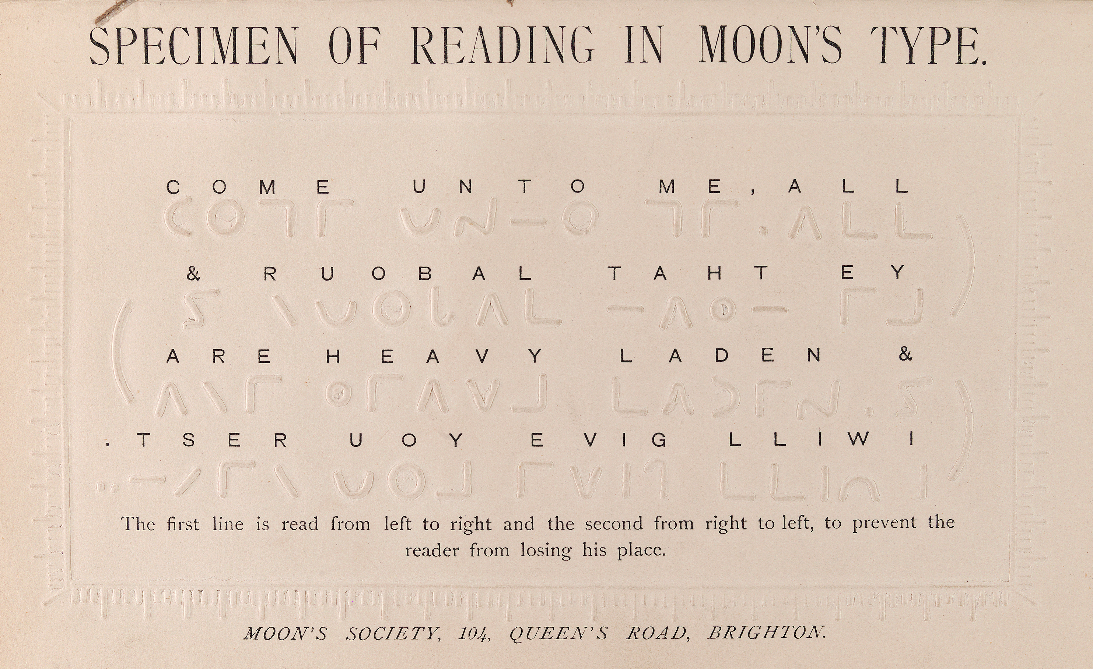

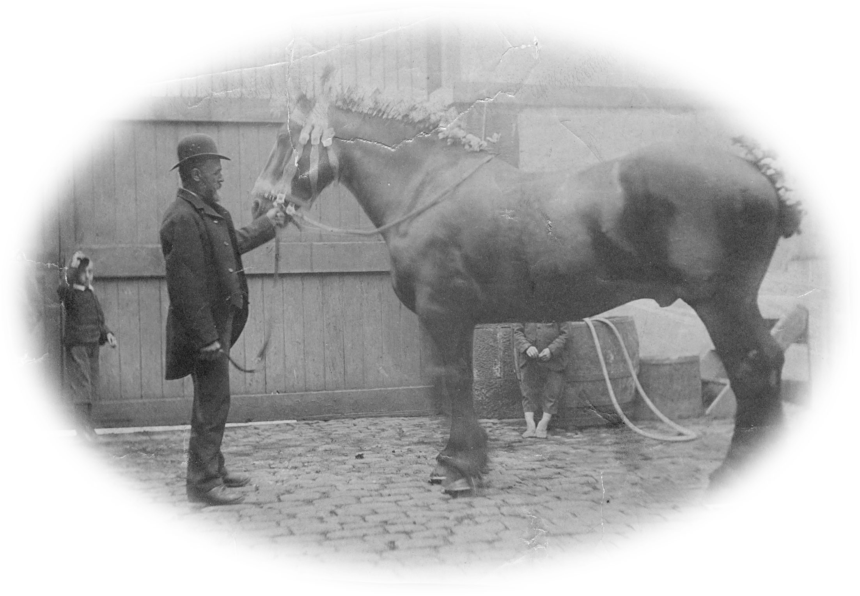
- William Finlay lost his sight as the result of a freak accident with one of the horses that were his pride. (Courtesy of Sheena Irving)

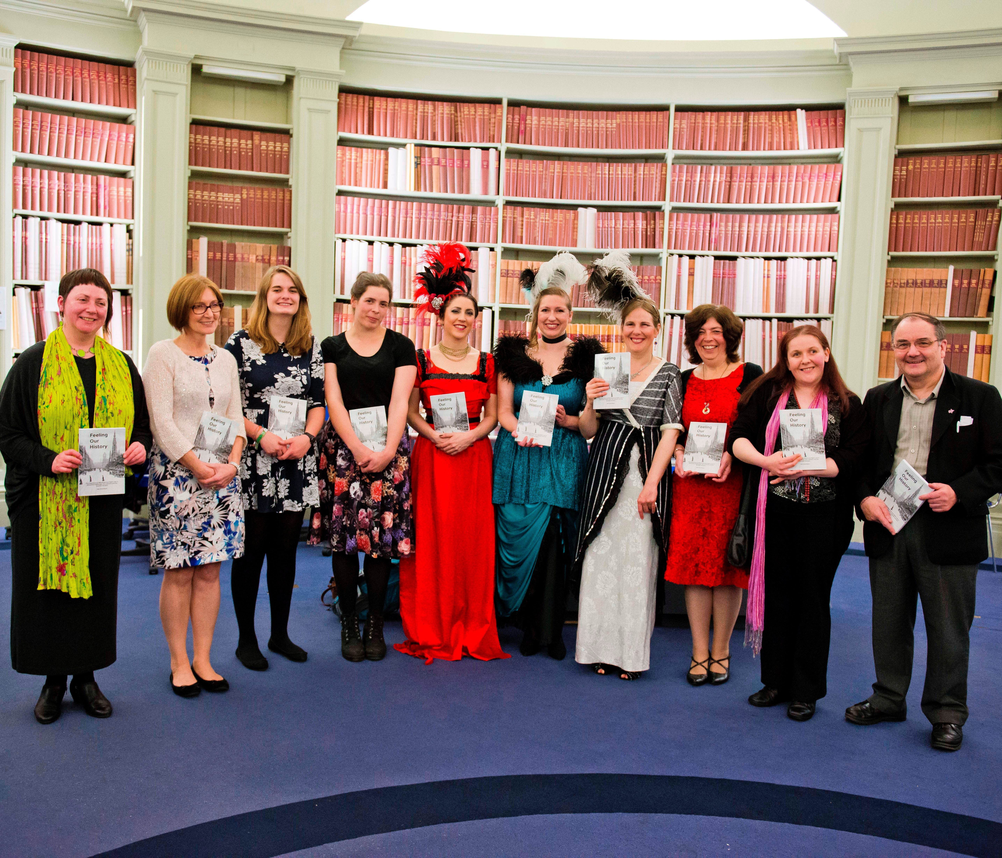
- The Team: Catriona Burness, Joan Kerr, Lizzy Ellicott, Veronica Bell, Sarah Caltieri, Siobhan Aitken, Sally Clay, Moira McMurchie, Victoria Ross and Iain Hutchison under the Adam Dome of the National Records of Scotland at the launch of Feeling Our History. (Photo: www.chriswatt.com)

