FALL 2009 DHA NEWSLETTER
© Disability History Association

The Fall 2009 Issue of the DHA Newsletter takes up the theme of public history with several articles related to disability history museums and exhibits, and other efforts to bring disability history to a public beyond the university. It also includes the second and final part of my interview with Henri-Jacques Stiker, author of A History of Disability (English trans. 2000), where we discuss the current state of disability history in France, and speculate on the future of the field. The Newsletter also contains announcements of new resources and conferences, and more.

MESSAGE FROM THE PRESIDENT 2
ANNOUNCEMENTS 3
New AFB Archives in New York City 3
Digitized Material on the Medical History of British India 4
Flikr and Disability History Photos Online 4
New Website on the History of Madness in Canada 4
NEW PUBLICATIONS FOR HIGH SCHOOL, UNIVERSITY, AND GENERAL READERS 5
The Encyclopedia of American Disability History, by Susan Burch 5
Polio, by Daniel J. Wilson 6
DHA @ AHA 7
BOOK REVIEWERS WANTED 8
NEWS FROM ACROSS THE POND 9
MEMBER CONVERSATION 12
Spotlight on Jennifer Barclay, by Lindsay Patterson 12
FORUM: DISABILITY HISTORY AT THE MUSEUM AND BEYOND 13
How A Curator Thinks, by Katherine Ott 13
Bricks and Mortar: Museum of disABILITY, by Theresa Frasier 16
A Matter of Integration: Disability History & The US Survey, by Laurie Bloch & Graham Warder 18
HISTORY OF THE BLIND IN FRANCE NOW AVAILABLE IN ENGLISH 24
INTERVIEW WITH HENRI-JACQUES STIKER – PART TWO 25

MESSAGE FROM THE OUTGOING PRESIDENT

Dear DHA Members:

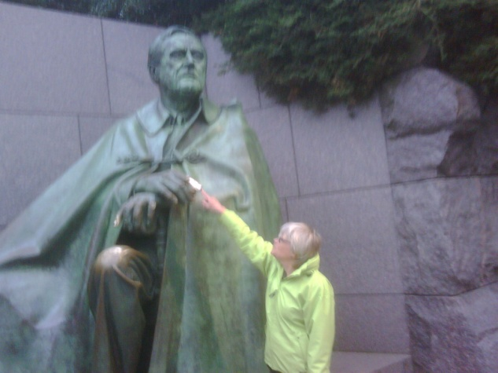
With this issue of the Newsletter I end my four years as president of DHA and editor-provocateur. I do so with mixed emotions. I have thoroughly enjoyed playing my part in helping transform DHA from a handful of dedicated scholars sharing informal fleeting conversations to a full-fledged organization recognized by both the Internal Revenue Service and the American Historical Association. While we are not rich (who is in 2009?!), we now have enough of a financial base to plan for a future that includes supporting young scholars. We are building partnerships with organizations in the United States and abroad. And we can congratulate ourselves that the upcoming AHA meeting will have five panels devoted to disability history as well as an increasingly more welcoming environment. I thank you for your contributions, your support, your emails of joy at finding others. We’ll look back on this time as one of extraordinary intellectual ferment and growth, a time when ideas were fluid, professional stakes were low but scholarly ones high, a golden moment when everyone had something to contribute.

Coincidentally, yet appropriately, the public history theme of this issue offers a perfect transition to our new president, Penny Richards of UCLA, who was unanimously elected by the DHA Board at our October meeting. An indefatigable researcher and advocate, Penny brings great energy, passion, common sense, and smarts to our organization. Most know her already as a founding editor of H-Disability and the always-welcome monthly “Current Journal Articles” feature. Penny has her fingers on the pulse of our field by following blogs, discussion lists in the realms of scholarship and activism related to disability. In fact, she has been a great advocate for information sharing of all kinds, including a longer-term advocacy for creating archives. I have especially appreciated her work on the DHA Board over the past several years, where I’ve often only half-joked that I need to create a “Thanks Penny, you came to the rescue!” macro. Firmly implanted in the contemporary world, yet also a terrific historian with a nose for the fascinating, revealing, sometimes heartbreaking story, our new president is well-suited to take DHA on the next stage of its journey.

As for me, I’m eager to throw myself into my new project on the history of smallpox in eighteenth and nineteenth-century France. This brings me back to my roots as a historian of epidemics (my first book was on social and cultural responses to cholera), but with the wisdom of our new field. I look forward to watching the DHA evolve and to contributing when and where I can.

In solidarity,

Cathy Kudlick
DHA President and Editor-Provocateur
AND FROM THE INCOMING PRESIDENT

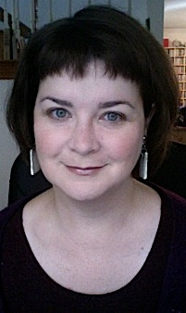
Greetings, disability historians! Let's first thank Cathy for an excellent term as president of the Disability History Association, and wish her well in her new projects. During her reign and because of her persistence, we became an official non-profit organization (so keep those donations coming). Also during her term, we had our first disability history conference in the US, and we became affiliated with the American Historical Association, which gives our field a place at the table in AHA conference planning and other important meetings.

As we move into the second decade of the 21st century--yes, already-- we hope to see DHA reaching out more and more. We have the base now, finally, to start funding student scholarships for conference attendance. We can start to realize some long-term goals for awards for outstanding research and publications. We are already making alliances with other organizations, such as the Disability History Group in the UK, to build a wider community of scholars in our field.

Cathy notes that one of my particular interests is in doing history that reaches beyond campus in its appeal and impact. The Disability History Association is well-positioned to be an excellent resource for schools, veterans' groups, rights organizations, local historians, and others in the community who seek and appreciate a historical perspective on disability issues. And in turn, those organizations can inform and support scholarship in ways we have perhaps only begun to imagine. As an independent scholar, I live and work "out here," and feel the need for such outreach. As a blogger and H-Net editor, I
know there are many available spaces for these productive exchanges to happen. I will be encouraging, cajoling, nudging us, as an organization, to be mindful of this broader potential in the coming year.

Penny L. Richards
Turley2@roadrunner.com

ANNOUNCEMENTS OF INTEREST TO DISABILITY HISTORIANS

1. American Foundation for the Blind (AFB) Announces the Opening of New Archives in New York City

The American Foundation for the Blind has moved offices. The organization is now located at 2 Penn Plaza, Suite 1102, New York, NY 10121. AFB has constructed a purpose built archival vault with temperature and humidity control to house its unique historical collections, including the Helen Keller Archive, the Talking Book Archive, its M. C. Migel Rare Book Collection, and AFB's organizational archives.

The new office space includes both a state-of-the-art archival facility as well as a gallery space for exhibitions. A glass paned window separates the vault from the gallery space, allowing viewing from either room. AFB intends to mount periodic exhibitions that highlight the richness of its archival collections. The first exhibition is scheduled to open in January 2010 and will present a selection of key Helen Keller items from the over 80,000 items in the archive. This exhibition, “The Many Faces of Helen,” will be the first of several intended to bring greater attention to her extraordinary life. Another exhibit will showcase the organization's unique Rare Book Collection. This collection of almost 1,400 volumes on non-medical aspects of blindness spans from 1617 to the 20th century and is one of the foremost collections of its kind in the world. Books - including Diderot's Lettre sur Les Aveugles à l’Usage de Ceux qui Voyent, 1749. (Diderot went to jail as a result of writing this book) and Précis sur l'Histoire de France, Paris 1837, which is one of only three known copies of the first edition of the first full-length book embossed using the braille system - will be on display for the first time and will shed light on almost 400 years of changing attitudes towards those with visual disabilities.

For more information on AFB's archival collections please contact Helen Selsdon at 212 502-7628 or email: hselsdon@afb.net

2. Digitized Material on the Medical History of British India with New Information on “Lunatic Asylums

From the National Library of Scotland blog, Jan Usher writes:

"We've been fortunate to be awarded more funds from the Wellcome Trust to digitise more material for the Medical History of British India Online project, this time the reports of the Lunatic Asylums. They're a fascinating resource for the study of mental illness, but also very revealing of social and moral attitudes of the day."

3. Flikr and Disability History Photos Online

There's a newish Disability History pool on Flickr, the photosharing website. Photos from archives and private citizens are invited to the group, from all places and eras. Right now we have architecture, aerial views, Australian sopranos, veterans of Gettysburg and Gallipoli, protesters, schoolchildren, scientists, signage, and statues. What else can you contribute? http://www.flickr.com/groups/1022796@N24/

4. New Website on the History of Madness in Canada

A new History of Madness in Canada / Histoire de la Folie au Canada Website http://www.historyofmadness.ca/ was launched October 31st, 2009.

Established by a collective of researchers and educators from across the social sciences, this unique site has been created to enhance critical thinking, heritage preservation and historical research in the fields of psychiatric medicine and mental health. We welcome national and international involvement from educators, researchers, archivists, psychiatric survivors, users, practitioners and advocates. While we are currently operating in English, we are committed to building a fully bilingual site.

We are delighted to announce that the website has been fully redesigned and includes the following new content:

News from our Five-year national project on the history of deinstitutionalization in Canada, Open Doors / Closed Ranks: Locating Mental Health after the Asylum.

E-Education: secondary school lesson plans which consider war and mental health; post-World War II definitions of “normal”; and the rise of the psychiatric survivor movement in the 1970s and 80s. Revisit these pages in December 2009 for the launch of Youth and Mental Health: Addressing Stigma through Community-Informed Curriculum, an innovative set of interdisciplinary multi-media teaching materials.

E-Archives: featuring an exhibit on mental health history in British Columbia; a chronicle of psychiatric history in Québec; and an anthology of 19th- and early 20th-century documents and personal accounts.

E-Library: offering an assortment of primary and secondary materials and a comprehensive bibliography of more than 800 sources on the history and culture of psychiatry, asylums, and mental health in Canada, with a strong presence of contributions from the psychiatric survivor and consumer communities.

Enjoy all of this and revisit the website to watch our projects and collections take shape.

For information please contact: robert.menzies@historyofmadness.ca or megan.davies@historyofmadness.ca

TWO NEW PUBLICATIONS BY MEMBERS ON UNITED STATES DISABILITY HISTORY FOR HIGH SCHOOL, UNIVERSITY, AND GENERAL READERS
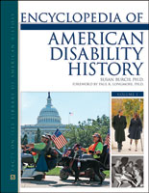

1. Susan Burch is pleased to announce the publication of the long-awaited Making History: The Encyclopedia of American Disability History, the first historical encyclopedia of disability in America. The 3-volume Encyclopedia of American Disability History (published by Facts on File) presents nearly 800 subject entries and includes more than 350 authors. The clear and accessible writing will enable high school students, the broad public, as well as university students and scholars to enjoy using this reference tool.

Twelve broad themes frame the encyclopedia: activism and advocacy, disability art and artistic expression, community, disability culture, daily life, education, employment and labor, identity, language and terminology, law and policy, representation, and science and technology. Working from a social-cultural model of disability, our authors address the complexity of disability history, addressing multiple perspectives and interpretations, and placing their subjects into the broader American historical context.

Basic factors, such as important events, laws, and biographies of people with disabilities are covered at length. Significant historic experiences and concepts, including asylums and institutions, civil rights, wars, public policies, media, education, protests, and assistive technologies, reveal the deeper meaning of disability as a lived experience. The explanations also make connections to race, class, and gender, as well as other critical categories, such as ethnicity, religion, and region. In addition to common topics in American disability history, this work features original studies that expand the field. For example, readers will find articles on camps, drama, ethnicity, family, humor, the Internet, poverty, public history, sexuality, sports, and violence.

In an effort to connect readers with the past and to highlight key themes
and features, we collected a wide array of primary sources to complement many of the articles. These include letters, interviews, paintings, newspaper clippings, photographs, cartes des visites, pamphlets, speeches, laws, song lyrics, and literary works. The encyclopedia also includes an extensive chronology of significant events in American disability history extending from the colonial period to present day. Throughout the volumes, breakout quotes from "common folks" offer insights into daily lives that typically have remained in the margins of historical study. The bibliography at the end of Volume 3 includes hundreds of books, articles, and documents, as well as sections on electronic resources: CDs, DVDs, video recordings, and Web sites.

It is hoped that this reference tool will spark additional research in the field. The editor and advisory board members offer our heartfelt thanks to the authors and other contributors who helped to bring this important project to fruition.

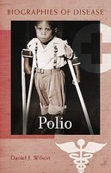
Print copies of the encyclopedia will be released in September;
digitized subscriptions will follow several months later. We hope that you will encourage libraries and organizations you know to purchase this important work. For more information about the encyclopedia, please contact Susan Burch at sburch@middlebury.edu

2. Greenwood Press has published Daniel J. Wilson’s Polio as part of its Biographies of Disease series. The book was written for a general audience, including high school students. The volume traces the emergence of polio as an epidemic disease in the late nineteenth century and the scientific and medical efforts to find a cure or preventive. It explores the development of Warm Springs as a polio rehabilitation center by Franklin D. Roosevelt and the subsequent creation of the National Foundation for Infantile Paralysis and the March of Dimes to support polio research and rehabilitation. Polio also examines the efforts of Jonas Salk and Albert Sabin to create successful polio vaccines. Finally, the book discusses the experience of having polio, of undergoing polio rehabilitation, and of living with a permanent disability. Polio also includes a polio time-line, a glossary of terms, and a bibliography.

DHA @ AHA, SAN DIEGO, JANUARY 7-10, 2010
Compiled by Dan Wilson

The Disability History Association is now an Affiliated Society with the American Historical Association, which means that this year we have the largest number of panels in our field ever. As an Affiliated Society we are sponsoring or co-sponsoring the following:

Thursday, Jan. 7, 3-5 p.m.
Rethinking American Disability Movement History
Chair: Penny Richards
“American Ideologies of Disease, Disability, and Charity: Clashing Late-Twentieth-Century Perspectives,” Paul K. Longmore
“Sweet Land of Disability: the 1977 Occupation of the HEW Offices and the American Stage,” Victoria Lewis
“Disability, Solidarity, and the Black Power of 504,” Susan Schweik

Friday, Jan. 8, 9:30-11:30 a.m.
Disability in a Global Perspective
Chair: Michael Davidson
“Constructing Legal Definitions of Physical Difference and Disability in Fifteenth-Century Mamluk Cairo and Damascus,” Kristina Richardson
“Does God Hear Silent Prayers? Deafness in Ottoman Syria,” Sara Scalenghe
“Using Disability to Rethink the Nature of Identity in Modern America,” Jeffrey A. Brune

Friday, Jan. 8, 2:30-4:30 p.m.
Constructing a National Body: Disability, Race, and Gender in the United States
Chair: Steven Noll
“Intellect, Feeblemindedness, and Civic Fitness,” Anna Stubblefield
“Diagnosing Defectives: Eugenic Fieldwork in the United States, 1910-24,” Sara A. Vogt
“Salvaging Human Wastage for the Great Industrial Army': Race, Rehabilitation, and the Federal Board for Vocational Education, 1917-24,” Paul R. D. Lawrie
Comment: Michael A. Rembis

Saturday, January 9, 2010: 11:30 AM-1:30 PM
Becoming Helen Keller: Perspectives and Experiences Integrating Disability into U.S. Survey, Higher Education, and Secondary School Coursework
Chair: Laurie Block, Disability Museum
Panel discussion with Richard Cairn, Hampshire Educational Collaborative, William F. Kuracina, Texas A&M University at Commerce, Laura L. Lovett, University of Massachusetts, and Graham Warder, Keene State College

Saturday, Jan, 9, 2:30-4:30 p.m.
Reclaiming the Disabled Subjects in Historical Research and Representation
Chair: Alice R. Wexler
“Interpreting and Archiving Mad People's History,” Geoffrey Reaume
“Materialism and the 'Disabled Subject' in Disability History,” Rachel Gorman
“Mother Made her Mad: 'Mother-Blaming' and the Pathologization of Female Juvenile Delinquents in the Twentieth-Century United States,” Michael A. Rembis
Comment: Susan Burch

Stay tuned for announcements of other DHA-related gatherings at the conference.

BOOK REVIEWERS WANTED FOR H-DISABILITY
From Iain Hutchison, H-Disability Book Review Editor: i.c.hutchison@stir.ac.uk

We are in the process of reviving book reviews on H-Disability and we hope that the first of recent reviews will be posted very soon.

Several people have already come forward to offer their services as book reviewers, books are currently out for review, and additional titles have been requested so that they may also be offered for review.

There are several ways that members of H-Disability can help create a vibrant review facility on the List.

Firstly, we invite people to get in touch if they would like to be offered a book for review. We would like a range of reviewers from PhD researchers to established scholars. Doctoral researchers should consider getting involved because book reviews represent one way of building up a resume – and it is the custom that you keep the books that you have reviewed!

So, if you would like to be a reviewer, send an e-mail to the H-Dis Book Reviews Editor, Dr Iain Hutchison, at i.c.hutchison@stir.ac.uk In your e-mail, please tell me about any particular areas of expertise that you would like to offer. However, if you can also contribute a range of broad knowledge on areas of disability history, this will increase our ability to send you a book for review. The information that will help is:

Your name:
Institution name and address:
Areas of disability history that you would be interested in undertaking book reviews – for example:-
Geographical expertise (France, Middle East, etc.)
Period (e.g. seventeenth century, 1918-1945, etc.)
Themes (deaf history, polio, education, biography, etc.)

Secondly, if you are aware of books relevant to disability history that you feel should be reviewed on H-Dis, please draw them to our attention. Helpful information will include name(s) of author(s) or editor(s); title of book; name and location of publisher with year of publication; and the ISBN.

Thirdly, and most importantly, if YOU have published a book within our discipline recently, please draw it to our attention. The work of our own H-Dis members should have full opportunity for exposure on the list, so please don’t be shy.

Please get in touch with me. I will be pleased to hear from you.

NEWS FROM ACROSS THE POND

From the UK Ana Carden-Coyne a.cc@manchester.ac.uk writes:

The Disability History Group UK/Europe now has a Facebook Group, and people can join it. The Group is for all those who use Facebook and are interested in the History of Disability. It will contain news, such as book releases, and also has space for a discussion forum. (It also directs people to the website www.disabilityhistory.co.uk).
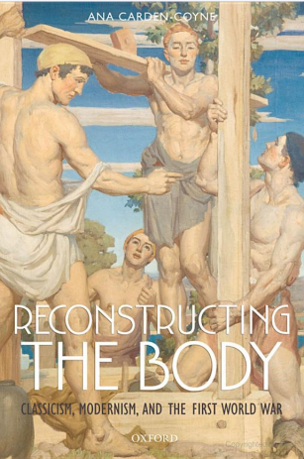

New UK research includes Ana Carden-Coyne's 'Reconstructing the Body: Classicism, Modernism and the First World War' - a disability studies and queer theory approach to the cultural and medical history of war (Oxford University Press). Ana Carden-Coyne investigates the cultures of resilience and the institutions of reconstruction in Britain, Australia, and the United States. Immersed in efforts to heal the consequences of violence and triumph over adversity, reconstruction inspired politicians, professionals, and individuals to transform themselves and their societies.


‘Defying Disability’ by Mary Wilkinson (Jessica Kingsley Publishers, 2009) tells the stories of nine disabled leaders who, by force of personality and concrete achievement, have made us think differently about disability. Whatever direction they have come from, they share a common will to change society so that disabled people get a fair deal. It includes compelling biographies of: Sir Bert Massie, public servant; · Lord (Jack) Ashley, Labour politician; Rachel Hurst: activist and campaigner; Tom Shakespeare, academic; · Phil Friend, entrepreneur and business consultant; Peter White, broadcaster; Mat Fraser, actor, musician and performer; Andrew Lee, activist and campaigner; Dame Tanni Grey-Thompson, Paralympic champion. ‘Defying Disability’ is based on extensive interviews with the subjects and the people who know them. It marks their similarities and differences, the forces that drove them to achieve, the impact they have had on policies and practice, and how the modern history of disability in the UK has been played out in their lives.

The DHG is also sponsoring a Disability History Conference next summer, which includes the following cfp:

Disability History: looking forward to a better past?
June 25th - 27th, 2010

University of Central Lancashire, Preston, UK

Plenary Speakers:
Professor Catherine J Kudlick, University of California, Davis
Professor Tom Shakespeare, University of Newcastle

Disability history has emerged in recent years as an increasingly popular sub-discipline of historical research, covering social, cultural, medical, practical, gendered, technological and linguistic aspects of the lives of those seen by society as having ‘disabled’ bodies and minds. The Disability History Group are pleased to announce their latest conference. ‘Disability History: looking forward to a better past?’ which promotes the DHG’s goal to advance research into the history of disability. It is hoped the conference will broaden the
scope of disability history and deliver fresh and dynamic perspectives on the way disability has been used to legitimate and understand norms, social relations, inequality, and oppression. This includes historical research into individuals, groups and institutions, as well as representations/constructions and perspectives on disability.

The overarching theme of this conference is ‘Where are we, how did we get here and where are we going next?’. To this end, the conference is dedicated to an evaluation of all aspects of disability history at regional, national and international levels. In ‘looking forward to a better past’, the DHG hopes to encourage lively and informed debate on
the current state of disability history; how the discipline has emerged and arrived at this point; and where scholars working in the discipline will go in the future. However, paper topics are not prescriptive – we invite potential speakers to consider the ways that their current research has emerged and its context within the sub-discipline of disability history.

The DHG invites panel or individual contributions from scholars and postgraduates working in this field, and is keen to consider papers on a wide range of topics. Papers covering all aspects of disability history, as well as papers on the historical and future development of disability history, are welcomed.

Abstracts of 250 words should be sent to Dr Martin Atherton: matherton1@uclan.ac.uk by March 31, 2010.

Primary Source Contributions Sought for a Nineteenth-century British and Irish disability history

Discussions are taking place with a publisher to add a history of disability set to an established series of volumes that bring together rare published works and selected primary sources contemporary to the period.

The disability history set would focus on the long nineteenth century from c.1780 to 1914. It would aim to encapsulate a good geographical spread from England, Ireland, Scotland and Wales and to represent a broad range of disabling conditions – mental, physical and sensory, but also specific impairing circumstances and conditions. The initial strategy is to approach this on a range of themes such as work, education, philanthropy, medical intervention, institutionalisation, family and personal relationships, poverty, policing and crime, religion, gender, bottom-up testimony, etc.

The initial task is to identify potential items for inclusion. In this respect I am keen to receive suggestions from scholars whose work encompasses this period and geographical area.

Identification of rare works and documents that might be considered should include author name, title of work, year-place-name of publisher – along with a brief commentary as to why this item is worthy for inclusion. For published works, the publisher will run the necessary checks to establish rarity value and will locate a copy of the publication if it is selected. For larger works, which could not be reproduced in full, you might like to identify a section or chapter which you consider to be especially important.

For primary manuscript sources, I would need a copy of the source, such as a photocopy, clear digital image, or accurate transcript. Primary sources which might be of interest include treatises from professional specializations, legal documents, parish records, workhouse or poorhouse accounts, institution regulations, diaries, personal letters and historical ephemera in general. Other suggestions will be welcomed.

Naturally, acknowledgement of all instances of assistance will be made in the publication.

Please do not hesitate to get in touch with me. This is a project that will benefit from as wide an input as possible. I look forward to hearing from you and will welcome your support.

Iain Hutchison PhD FRHistS
School of History and Politics
University of Stirling
Stirling FK9 4LA
Scotland
i.c.hutchison@stir.ac.uk

MEMBER CONVERSATION:

LINDSEY PATTERSON INTERVIEWS JENNIFER BARCLAY
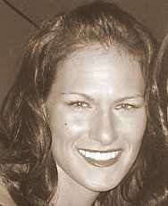
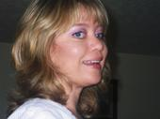

Getting to Know Each Other:

A Spotlight on Jenifer Barclay
By: Lindsey Patterson
DHA Board Graduate Student Representative
(Patterson.586@osu.edu )

Jennifer Barclay Lindsey Patterson

The field of disability history is quickly growing; however, many graduate students still find themselves the lone disability historian, or, if lucky, one of a few in their departments. Therefore, it is important that we emerge from the depths of our departments and libraries to get to know each other. It is my hope that this will be an ongoing section in the newsletter, highlighting the work of fellow graduate students, celebrating their accomplishments, and seeing where the next generation of disability historians is taking the field.

This past month, I had the pleasure to have a conversation with Jenifer Barclay, a doctoral candidate at Michigan State University and a 2009-2011 Carter G. Woodson Institute Fellow at the University of Virginia. Her work, “‘Cripples All! Or the Mark of Slavery’: The Invisible Link between Disability and Race in the Old South and Beyond,” combines intellectual, cultural, and social histories to examine the relationship between slaves and disability. Barclay brings a disability lens to the Old South, highlighting the relationship between race and disability and broadening the field through exploring the effects of medicine and law on crystallizing this relationship, which had a lasting impact on American culture throughout the nineteenth and early twentieth centuries.

Barclay’s work challenges the scholarship on the Old South’s able-bodied assumptions through highlighting the lived experiences of slaves with disabilities. While she focuses one chapter on the lives of disabled slaves, her work will primarily address the intellectual history of racial categories in the Antebellum South through the lens of disability. To do this, Barclay has had to be creative in her methodology, examining the rhetoric of disability in the Old South as well as re-reading the histories of science and medicine.

Barclay has found success in getting non-disability focused grants and fellowships. She attributes this success to the strength of the argument that the study of disability is essential to understanding the narrative of U.S. history and to the ability of the lens of disability to change our understanding of history. She also draws on established scholars in the field of disability history to show that there is a strong foundation of scholarship for her work. She also cites her ability to make her work interdisciplinary, which has brought her research into the mainstream and helped her not only to network with people in other disciplines such as English and Sociology, but to also emphasize the vitality of her project.

Barclay’s main piece of advice for graduate students is a useful reminder: network, network, network. She attended the Disability History Conference in San Francisco in 2008, where she met many other people in the field. Jenifer especially attests to the value of making and maintaining connections with senior scholars in the field. As a final thought, the American Historical Association conference in San Diego is rapidly approaching and I encourage graduate students to attend the panels on disability and network with other historians.

FORUM: DISABILITY HISTORY AT THE MUSEUM AND BEYOND

Many exciting and creative efforts are bringing disability history to a public beyond the academy, most notably in the area of museums. At the same time, the Ivory Tower has much to learn from these talented, smart bridge-builders and savvy fund-raisers. The three articles below offer a unique take on how to bring people and ideas that have long been missing in the historical record to the museum. How do we convey what might perversely be called the tangible-intangibles of disability experience in terms that are useful to today’s public without being overly sentimental or presentist? What challenges and opportunities does access – in every sense of the word – bring to rethinking the high school curriculum to incorporate disability in a natural way that still causes students and teachers to question their basic assumptions? While this forum converged spontaneously and not consciously, I suspect the invisible hand of serendipity at work, and I hope you find the result as stimulating as I do.

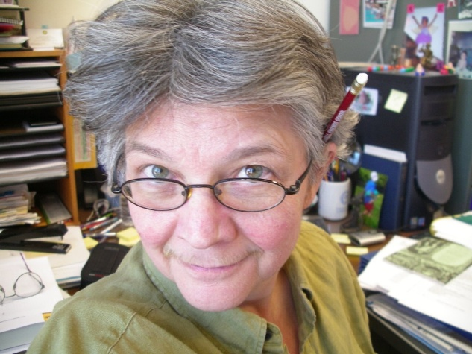
History and Disability the Way a Curator Thinks
Katherine Ott, Smithsonian Museum of American History (ottk@si.edu)

Ten years ago, when I started working as a curator here at the Smithsonian’s National Museum of American History, I had a very steep learning curve. Although I had had a couple of courses in archives and public history, history graduate students at Temple University in the late 1980s were given little, if any, training in how to use non-print material as primary sources. This largely remains true today, throughout history departments across the United States.

Competency in material culture is difficult to develop because academic departments are text-based and usually chauvinistic about it. I see this same steep intellectual climb recapitulated with colleagues whom I get to advise me on museum projects. It is very hard for scholars trained to privilege words to switch gears and embrace the sensory nature of historical evidence. How do you document history through its material record? How do you cite an object? How do you figure out what words and objects and images will communicate in a gallery setting from looking at the information on paper? Thinking through objects requires a different way of approaching information from the one we learn in school. It requires imagining other peoples’ bodies, desires, and frustrations, as well as being open to the sensory messages that every environment produces.

The basic tool of curatorial work, in collecting objects and mounting exhibits, is to think with your senses. Several years ago when I was trying to find artifacts for a small exhibit on the history of the disability rights movement to mark the tenth anniversary of the ADA, I sent out a short questionnaire to web groups where people with disabilities hung out. I also asked people to forward my questions to everyone they knew. This was crucial for both getting a handle on the exhibition and to building our collections, which were heavily oriented toward medicine and people as “cases” rather than their lived experience. I needed help from people with first-hand knowledge in order to retrieve the material record that we were missing. One of the things we collected was half of a hand-cuff from Diane Coleman. She had been arrested during a Not Dead Yet protest in which she had secured herself to an entrance to block access. The police cut off her hand-cuff and arrested her. The cold metal broken hand-cuff captures the struggle for autonomy, respect, recognition, and especially survival that so many people experience daily. There is no combination of adjectives, verbs, and nouns that can adequately explain what this artifact means. The strength of the steel is a metaphor for Coleman’s resolve. The fact of the police severing the cuff from her wrist triggers the imagination in dramatic, emotional ways that words cannot replicate. Without knowing anything more about the mission of Not Dead Yet, we know a huge amount about what propels their work through the hand-cuff. The hand-cuff was part of the exhibition and then later borrowed by the Constitution Center in Philadelphia for their exhibition on the first amendment.

Artifacts are about as close to the truth as a historian can get. We uncover facts and accumulate evidence and statistics, such as when something happened, who was there, the names of places. But as soon as we start explaining causation, motivation, consequences, we are on shaky ground. Historians can never know for sure why something unfolded as it did. We are stuck with informed inference, based upon our training and knowledge of similar occurrences. Most of the craft of history is interpretation based upon best guesses--we fill in narrative around the facts that we have. And in a few years, our interpretations will be revised by up-start students who have more information or different frame-works upon which to draw. Objects, however, don’t change. They are statements about the past and one of the few ways a historian has to actually bring people from the past into the present. They create a presence for people long gone and often anonymous. As evidence, they may be interpreted in many ways over the decades, but in form and structure, grounded in space and time, they do not deviate. The museum has three grave-markers from the institutional cemeteries in which in-mates were buried. Nearly every state has such sites, with markers that have only numbers—no names or dates to animate memories of the person buried beneath. For most of us when we die, the only thing that remains (other than all of our stuff which gets dispersed or discarded) is a marker somewhere with our name and dates. We know next to nothing about the thousands of people in these numbered graves. The numbered markers spark anger, despair, sadness, and a host of other emotions. And although they are anonymous, they are none the less the source of a vivid presence. One marker in the museum’s collections is from Milledgeville, Georgia, one from Faribault, Minnesota and another from Newark, a village in up-state New York. Each marker tells a truth, better than any interpretive moves we historians make.

The fraught thing about putting objects into exhibitions is that editorial judgments need to be made about what to say and where to place them. Interpreting historical objects is overlaid with the danger of misperceiving or being misled by the record. No one can know what another person experiences, no one can really understand the life and world of other people. It is hard enough to comprehend the lives of middle-class European-descended typically-abled men, for whom there is ample material. What of the anonymous and marginalized people, such as women, children, the poor, and especially people with disabilities, who leave few textual traces or evidence? I rely heavily on my friends and colleagues, to get a sense of the pertinent questions to ask. But when dealing with issues of embodiment, presentism is an unsolvable problem. The experience of having a disability in a world with paved streets, aspirin, the internet’s vast information, and mass media is far different from one without those things and it is impossible for us today to recreate that state of being. As is clear to everyone working in disability studies, once you know one person with a disability, you only know one person. But curators do exhibitions.

This past spring, Susan Burch and I immersed ourselves in drafting a script for a possible traveling exhibition (contingent on the availability of funding) on the history of disability. After intense mutual cogitation, we established the arc of the narrative, based upon 1) the material record already in the museum’s collections and what we believe is available elsewhere 2) the one main idea that we think most people should know about this topic (that people with disabilities have always existed and if you look at familiar historical themes through a disability framework, what you think you know undergoes surprising change) and 3) a few big, common, easily digestible, historical themes that are particularly important in the history of people with disabilities. Once we narrowed down the content in this way, we drafted labels for as much as we could with what was at hand. The next tasks, in addition to raising the funding for the exhibition, are to locate and acquire the objects we’ve identified but don’t have, fill in and edit the script text, link the script to the selected objects and images, create a website, get a designer on board to design the show, build the thing, and get it booked and on the road. These things happen simultaneously, of course. The script is constantly shifting, as we acquire some objects and give up on finding others. The core of the work is how to get objects to express themselves and get visitors to absorb the meaning.

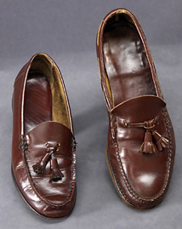
In a 2005 exhibition on the history of polio (www.americanhistory.si.edu/polio), Whatever Happened to Polio?, we wanted to get across the point that many people who had had polio had lasting physical consequences. Their bodies were different in ways that made it difficult to find comfortable furniture and clothes that fit.to take public transportation or drive a car, and do some everyday tasks. We did not want to reproduce the stereotypes of over-coming or pity or be heavy-handed about bodily difference. In conversations with people who had had polio, I heard about shoe buddies and clubs where people with a significant difference in the size of each foot could find other people who matched them in sizes, gender, and taste and exchange shoes. Exhibiting a pair of obviously mis-sized shoes seemed like an exemplary way to get the experience of bodily difference across. As I was scheming about how to wiggle my way into the shoe buddy community, luck arrived in the shape of Tobin Siebers. I met him at an SDS meeting. We talked about polio and shoes and he told me about a short story he had written related to his difficulty in getting shoes. He usually had to buy two pairs but when cleaning out his mother’s closet after her death, he found the exact match to his favorite red loafer. He wore her shoe when he got married. The happy part for us was that he donated the shoes, a copy of the story, and a photograph of himself on his wedding day. The shoes and their accompanying context were pitch perfect. It is this combination of artifact, experience, and historical event that the current exhibit strives for, as well.

Timelines for these sorts of exhibition always inject the elements of surprise and frustration. In a sense, we have been planning for this show for over 50 years, if you begin counting from when some of the objects were acquired. In more realistic terms, it will take 2-3 years, from approval to launch and include a team of about thirty people. Large exhibits with numerous objects and more audience testing may take 4-5 years to plan. The actual design and building of this 1500 square foot show will take about six months. But internal review committees need to approve the topic, concept, design, and use of museum resources, which takes time and lots of smiling and smoozing. We are incorporating universal design at all levels, from type fonts and color palettes to language and alternative formats. Once the show opens, there is on-going publicity, public programming, booking/crating/shipping/installation, facility reports on security and environmental conditions, docent training, and responding to visitors, related to each venue. The numbing managerial juggling is redeemed by the pleasure of sending out an opening reception invitation that asks, “Will you need a chair or be bringing your own?”

Bricks and Mortar: Museum of disABILITY History, Buffalo, New York
by Theresa Fraser (tfraser@people-inc.org)
www.museumofdisabiltiy.org

The Museum of disABILITY History is the only “bricks and mortar” Museum dedicated to advancing the understanding, acceptance, and independence of individuals with disabilities. The physical home of our Museum is accessible, although relatively small and can only accommodate around twelve visitors at any given time. Finding a larger facility to become our “permanent” home has been identified as one of our top priorities in our strategic plan. We are currently in the process of purchasing a new building in the Buffalo area which is ideal to house our growing collection. We expect to move to this larger facility and host a grand re-opening in the summer of 2010.

Our “virtual” home (www.museumofdisability.org) houses additional exhibits as well as catalogs to search our collections and archives. Our website has two versions, a flash-based version, and an accessible HTML version. Viewers have a variety of accessibility options, from short, medium, or long descriptions to changing colorchemes as well as text size options. Our site is divided into six separate wings, each showcasing specific exhibits relating to Disability History. We also feature a teacher resources section which includes our newly developed Disability History lesson plans for grades K-12.
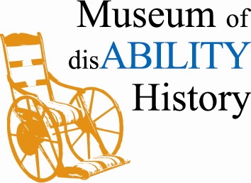
Our Museum was founded in 1999 by Dr. James Boles, the President and CEO of our parent organization, People Inc. Dr. Boles was teaching a Disabilities class at UB and was surprised to learn that there was a lack of Disability History resources available to students and researchers. He made it his mission to create the first ever Museum of Disability History. The museum started as a small collection of materials and one small traveling exhibit. It has now grown to house over 4,000 items, exhibits covering a variety of topics both in our “physical” and “virtual” realms, and a constantly growing research library.

The exhibits in the Museum consist of reproductions of images of people, buildings, documents, and objects that are related to the history of people with disabling conditions throughout time. The exhibits also feature objects that were used by people with various disabilities, such as crutches, eating and drinking utensils, wheelchairs, and ceremonial objects.

The Museum’s exhibits have a primary focus on Intellectual Disability, but also touch on the social concept of disability, the condition of being “different.” The Museum tries to show the reaction to and treatment of people with disabilities as Society’s understanding of disability evolves.

The Museum purchases a number of items for the collection, but we also have had some very generous donations from the general public, and people and institutions involved in the disability community.

We have a wide variety of visitors from individuals with disabilities and their families to students, and human service employees. We are open to the public Monday-Friday from 10-4. Large groups can call and schedule tours in advance. We have a specialized research library consisting of an array of rare books and periodicals. Due to the rarity of the items in our collection, our library is non-circulating. Researchers are welcome to come to the Museum and our staff will gladly assist them with viewing items from our library and archives, utilizing our microfilm reader, or making copies of delicate materials. We have a private room available for individuals to conduct research in a quiet setting.

Our Museum has worked with a variety of local colleges to conduct outreach presentations on disability history, awareness, and etiquette, as well as in-services outlining the availability and use of our newly developed Disability History Curriculum for grades K-12. The lesson plans are aligned to New York State as well as National Learning Standards and are available for free in the teacher resources section of our website.

We work with several colleges in the area. We have an ongoing relationship with Buffalo State College, frequently completing internships with students from the Museum Studies Program. More recently, we teamed up with the University at Buffalo to establish the first Center for Disability Studies. The purpose of the Center is to encourage the study, teaching and accurate representation of disability history and of individuals with disabilities. The Center will sponsor a visiting scholar for one semester each academic year beginning with this upcoming spring semester.

Our parent organization, People Inc. is a not-for-profit, organization that services the counties of Erie, Niagara, Wyoming, Chautauqua, Cattaraugus, Orleans, Genesee and Allegany. People Inc.’s exists so that individuals with disabling conditions or other special needs have the support they need to participate and succeed in an accepting society. People Inc. was founded in 1971 by a group of parents, professional and community members concerned about the quality of care provided to individuals with developmental disabilities. The agency has grown over the past 30 years into one of the largest human service agencies in Western New York, offering an ever growing multitude of services to meet the evolving needs of our service population.

Our current priority is to relocate our Museum to a larger, permanent facility. We are planning to redesign our exhibits and add some new, interactive exhibits in our new facility. We expect to be moved and ready to open sometime next summer (2010). With additional archival storage space, we can not only house our growing collection, but acquire larger items including objects that we were unable to house before. We plan to continue to expand our collection, create new exhibits, and remain a valuable educational resource to not only our local community, but our National audience as well.

A Matter of Integration: Disability History & The US Survey
Laurie Block with thanks to Graham Warder
info@disabilitymuseum.org

Note: Come discuss the following in person at the AHA session, “Becoming Helen Keller: Perspectives and Experiences Integrating Disability into U.S. Survey, Higher Education, and Secondary School Coursework” Saturday, January 9, 2010: 11:30 AM-1:30 PM

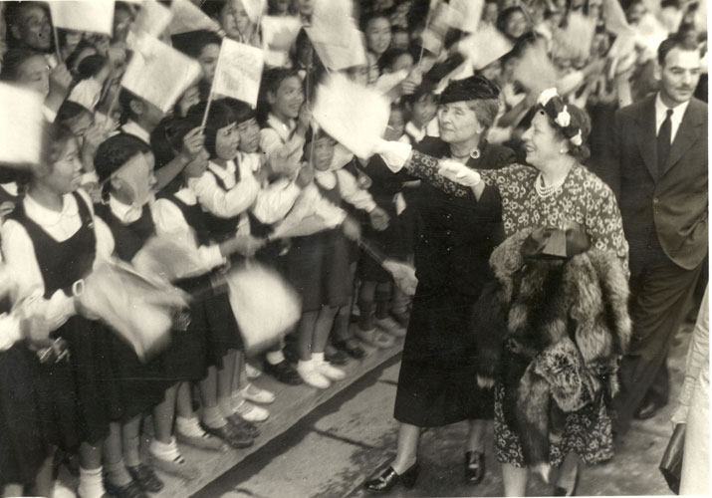
What was a museum in the 19th century? How would a family living in Ohio or in Kentucky find out about a school for the blind in the 1850s? How have the causes of blindness and deafness changed over time? How are the demographics of contemporary disability similar to or different from those of the 19th century? And what exactly did the Socialist Party propose in its 1904 platform?

These questions are just a sample of those we have been asked over the last two years, as we worked with a group of six high school history teachers, each from a different school, on a project called Becoming Helen Keller: Integrating Disability History into the US Survey, funded by the National Endowment for the Humanities. The project has had several other names, including “Helen Keller and Her Times” and “Interpreting Helen Keller,” but we have decided to keep the curriculum aligned with a film documentary currently in production for the PBS American Masters series with a broadcast date anticipated in late 2011. The promotion for both products should enhance the reach of each product to different audience niches.

Becoming Helen Keller, the curriculum, is being produced by three partners, Keene State College, led by Dr. Graham Warder; the Disability History Museum, www.disabilitymuseum.org, led by Executive Director Laurie Block; and the Hampshire Education Collaborative’s Professional Development Staff, led by Richard Cairn. There is a team of academic advisors involved with the project, but central to the work’s development process is a team of six secondary school teachers. Each of these history teachers comes to the project voluntarily, and they represent entirely different types of school districts in western Massachusetts – different in terms of class, geography (rural, urban, and suburban), financing (public and private), and ethnic and religious backgrounds. All are paid a small stipend to work with the project partners, and all have shown up faithfully for evening meetings during the school year and to an annual daylong workshop over a period of two summers.An earlier iteration of some of this work was piloted with several teachers from Newton North High School in eastern Massachusetts, and many of those early formative evaluations helped shape the more recent work. [Western Massachusetts is characterized by medium sized cities and small towns, many with economies that have not picked up since the precision tool industries that used to flourish here moved offshore or closed, and, rural communities that also struggle for stability. Healthcare, the numerous colleges in the region, and insurance companies provide the majority of the regions jobs.]

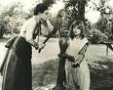
A word about the Disability History Museum. This project began as an outgrowth of the website associated with the NPR radio series Beyond Affliction, produced by Laurie Block with Jay Allison. Established in 2000, it is an entirely online effort, one supported by donations and grant funds. Its mission is to foster deeper understanding about how changing values, notions of identity, laws and public policies, have shaped and influenced the experiences of people with disabilities, their families and communities over time. It is a work in progress, and the site has grown slowly but steadily. It hosts a growing study collection in its Library, and in this article the curriculum work, currently in production, that will open the project’s Education sector is described. Further, in relationship to this effort, a new iteration of the website will be coming online near the beginning of 2010.

Our Becoming Helen Keller pilot project teachers of course knew Helen Keller’s name and the story told in The Miracle Worker. With one exception–a teacher who worked in a private school for the deaf–none of them knew anything about disability history. The tasks this group had were significant, and were key to the partnership’s curriculum development process. We periodically gave them mounds of primary source documents to read, arranged in loose chronological groupings with vague themes. The documents were all related directly or tangentially to the biography of Helen Keller. But we emphasized that the curriculum we were developing would not concentrate on the details of Keller’s personal life. Rather, it would use those details -- the experiences she had, and her long life’s legacy -- as a vantage point to look at topics in disability history, topics affecting a broad population, able and disabled alike.

The teachers burrowed into these mounds with gusto, and sometimes an occasional groan. Their assignment was to identify which primary source materials among the too many provided were most interesting to them personally and which were most useful for developing lessons for their students. They then had to identify specific paragraphs within a source they especially liked and to explain to us why, and what pedagogical objectives they would use them for when teaching one of their own survey classes. In other words, they had to weed down to what they thought the best materials were and then explain to us why their choice was a good fit. Along the way, they often related how they would use the work in an assignment, and what additional materials they would need personally and for their students to understand the primary source better.

From the very beginning of this project, we understood that the students would face the curriculum without knowing a world before curb cuts and guarantees for special education. We had to introduce our topics, provide key texts, and delineate milestones in policy or technology or cultural attitudes. We also had to connect disability history with what they already taught. In earlier surveys of high school teachers we were told quite clearly that although they might have a significant interest in learning more about disability history as a subject, a curriculum about such content would have to integrate it within traditional themes, topics, political turning points, and social movements, as typically taught in the US History Survey. They had little doubt or hesitation that any other approach would be rejected by many otherwise interested teachers simply because they already needed to cover so much to meet education reform standards and standardized testing requirements. Time was very precious in these classrooms.

Helen Keller, as she often did in her own lifetime, provided brand recognition and a myth ready to be deconstructed. Although there is increasing recognition that Keller grew up into an advocate, a suffragette, someone who had radical opinions and even a Socialist Party card, when we ask what she actually did, more questions arose. What was her education like? How did she earn her living? How was her search for economic independence like or unlike that of other people with disabilities in her own day? How did she become one of the first real-life child media sensations, and later one of the first global media stars? Why did her life story have the power it has, and why does it still have some of that power? It quickly becomes apparent that answers to these questions are not readily available, but that the curriculum must take them up –directly and indirectly.

Keller lived from 1880 to 1968, and the volume of her correspondence and print record (speeches, articles she wrote, and the newspaper coverage about her), not to mention the photographic and film record, provides plenty of primary source material as a starting point. Much of it was similar; from decade to decade it cycles a set of themes, a constant rhetoric both verbal and visual, and a fixed number of gestures and postures. The focus of her own writing and speech-making was on the importance of education and employment for the blind, the deaf, the disabled, women and the poor. Keller spoke about all this in a lofty, spiritualized, socialist call for attention and justice. Her personal letters, and those of many people around her, were far more spontaneous than her public utterances, but we will never know many intimate things about her because one large set of materials was destroyed in a house fire in 1946 and another set of materials related to her international work was destroyed in 2001 when the World Trade Center Towers fell and the offices of the American Foundation for the Overseas Blind were destroyed.

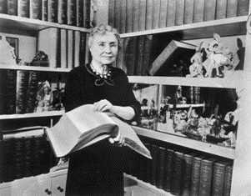
We knew when we began giving notebooks of primary source materials to teachers, they would come back to us wanting to understand what it was they had just read. But how would they shape their questions? Our materials were so novel that we could not refer to textbooks, nor could we rely on standard secondary source materials, though everyone in the room knew The Miracle Worker tale – which, in a way, is one of the burdens of the project that we first had to resolve. The initial questions about Keller always quickly go back to the basics–how did she learn to communicate? And in more than one language? And read Milton and Shakespeare? Was it sign language or the manual alphabet, and how are these two modes different? How were they understood in the late 19th century? And where did you send a child who was blind or deaf to school? What kind of education were they provided? And who paid the bill?

In the very earliest version of this curriculum work, we did not have Keller as a character; we addressed these questions by concentrating on the establishment of deaf schools. But in a team evaluation of our materials, the public school teachers we worked with argued that for their classes a focus on deaf education, though interesting, was too narrow. Connect the deaf schools to something bigger, they said. And as we talked around our Keller curriculum seminar table and discussed the establishment of residential schools for the deaf and the blind in relationship to the founding of schools for the “feeble-minded,” they insisted we include more. We talked about the founding of schools for people with disabilities as part of a reform movement inspired by the Second Great Awakening and how it was related to the establishment of common schools in the same period.

Those relationships are easily described. More arduous has been finding the best documents to illustrate the historical connections. Once we select a suite of appropriate primary sources with the teachers, we also begin a process of annotating them and developing introductions for each one in order to contextualize the content both for teachers and for young people. They need to be informed about who was who and who did what: Samuel Gridley Howe and Horace Mann, Thomas Gallaudet and Laurent Clerc and Mason Cogswell. How were their efforts to establish their various schools similar and different, and how intertwined with other education reforms? But we found ourselves also having to address very basic questions about schooling for a typical child in the 19th century, and how it might vary from region to region! Only with this background established could you get on to Keller’s education with solid footing. Only then did the teachers we worked with feel comfortable with explanations about the debates over oralist and manualist methods for deaf education, or the fact (shocking to many) that four different and incompatible types of raised print competed for space on library shelves in schools for the blind (Braille was not the standard mode of tactile print until the 1930s).

Another example: To discuss the significance of why Keller as a child was regularly asked to display her ability to communicate, and to explain the audience responses of the period, we needed to provide some context for the exhibition of human differences in the 19th and 20th centuries. Keller would demonstrate her abilities often as a child, but she came to tell her life story as a part of her public speaking again and again. Sometimes she did so within forms of performance that were entertainment–she was a well paid act in vaudeville between 1920 and 1924, and she was a popular memoirist, but for 25 years and more her public speaking was as a professional fundraiser for the American Foundation for the Blind. Her journeys for the U.S. State Department in conjunction with overseas nonprofit organizations during the Cold War had the flair of a goodwill ambassador’s visits, but also had the purpose of attracting funds to various useful health care, social welfare, and education causes. But how did audiences understand what she did and said back then, and how do we hear this message today? How do we bring Helen Keller, and disability history with her, into the classroom? Any faculty or graduate students interested in interning or working on this type of problem, do please inquire by writing info@disabilitymuseum.org.

Several lessons within our curriculum modules take up this topic of Keller’s performances. We begin our look at public performances with a lesson that studies P.T.Barnum’s displays of Charles Stratton (known as “Tom Thumb”) and his wife Lavinia Warren. This lesson compares the souvenir pamphlets and photographs that were distributed about them, a set of highly constructed autobiographies and images, with similar advertisements and written materials about the “Siamese twins” Cheng and Eng and the musician Blind Tom.

Christopher Gould piloted these materials in his Amherst High School class and found that the students had to work hard to grasp the experiences of these people, but they were riveted. These characters just lived really different lives! Gould discussed matters of agency, asking how they had come to find their jobs in show business. They discussed what other possibilities for employment existed for any of them and whether or not the built environment facilitated jobs for little people, conjoined twins, and a non-verbal but gifted African American musician. He talked about how much they earned, how the money was divided, and how Cheng and Eng could end up with a number of slaves and children -- his quite talkative students were left speechless when they realized the number of descendants these conjoined brothers produced.

To provide this lesson with sufficient background required significant preparation. One of the first questions our teachers asked us when discussing Barnum was what the word “museum” meant in the 19th century. We had to provide a context for the souvenir fictional autobiographies associated with Barnum’s American Museum human exhibits, and give a sense of the range of entertainments then available. For this unit they found a variety of materials on several different websites. Still, the souvenir autobiographies and the ads facilitated a wide ranging classroom discussion with our teachers, but then they found this to be true with their students. To talk about the exhibit of human difference in the 19th century required discussing how Darwin’s ideas permeated popular culture, how social Darwinism evolved, the idea that disciplines of study such as sociology and anthropology had very few tools and almost no authority in the 19th century, that communication tools such as advertising were just coming into a mass-market world. All these ideas were enthusiastically explored. And this helps set up discussion of Keller’s public life, how and why Keller did what she did given the available choices.

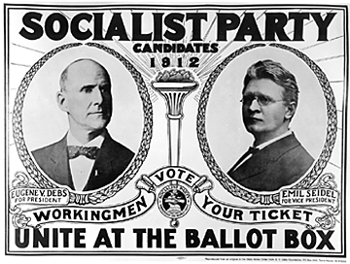
A lesson constructed around a comparison of Keller’s “How I Became a Socialist” with Eugene Debs’s essay of the same title prompted a different series of questions. Working at a Catholic High School in Holyoke, Massachusetts, an economically depressed community, Catherine Peters used these two documents when discussing populism, multi-party divisions, and the turn-of-the-20th-century electoral landscape. Her students seemed genuinely stumped when asked what a socialist was. But Keller’s and Debs’s statements led to a discussion about who gets to decide how goods are distributed across all classes and groups in society. The lesson also provides an opportunity to look at this question in the context of a world without anti-discrimination law, civil rights guarantees in education and employment, fair labor regulations, and civil liberties guarantees. All these topics needed background essay support -- what another teacher in the group called “lecture bursts”, short, well written, contextual pieces that help someone who did not have the opportunity to sit at our seminar table come to the material and feel grounded. When these essays are completed for this lesson, they will include where and how people with disabilities fit into the issues of employment policy, labor struggles, and political debates about poverty and economic rights in 1904. We all agreed that the Socialist Platform of 1904 -- which included a graduated income tax, unemployment insurance, old-age pensions, workmen’s compensation, free public kindergartens, improved school buildings, free legal advice for the poor, and free cremation services -- would also be part of the primary source materials.

This last example about Debs and Keller brings up another point. The production team developing the curriculum has been asked to incorporate into the materials something not initially built into the design of the project, but increasingly useful to teachers working with Smart Boards and media-saturated students. All our high school teachers point out that a contemporary hook that they can use to lead into the historical material helps to focus their classrooms. But they strongly suggested that the hook on which a set of questions for young people can best be hung should be interactive -- just as we see the online New York Times developing, for example, a health insurance time line, or data visualizations during elections that show state by state swings in voting preferences from Democratic to Republican and back again.

The teachers we work with universally seek out these kinds of tools as they prepare for their classes. Timelines can be produced with a moderate amount of work, but representations of quantitative, longitudinal information, though extremely useful, are much more costly, requiring research and digital tools not always available to small producers. But it would be wonderful indeed to display visually just how a population called “blind” or “visually impaired” or “deaf” changed over time, how during Keller’s lifetime the services offered changed and where they were provided changed, or how employment rates for those labeled as belonging to these groups changed -- or did not change. Building such tools remains a hope for the project, one that the funding currently available does not allow us to realize.

Developing a disability history curriculum that will hold up as stand-alone professional development is labor intensive and financially expensive. In addition to identifying, digitizing, and cataloguing the primary sources, we must also make sure they are useful for teaching and provide sufficient support to contextualize the historical records. To do that work, we’ve used a small team of graduate students and recent Ph.D. candidates, including several members of the DHA. When publishing on the web, there are the usual editing processes, but also the need for technical fixes that make the online work accessible. This means our team must combine pedagogical, historical, and information-management skills, as well as financial development and management. The effort of raising the funds to keep staff and freelancers paid is not inconsiderable.

We have about six to nine months of work ahead to complete the Becoming Helen Keller curriculum. Along the way, we have built and designed a completely new iteration of the Disability History Museum that will come online, slowly, toward the end of this year. When we open this new interface late in 2009, we will have about six to eight lessons available, and as the background essays and copy editing, annotations and introductions for the next 24 lessons are completed, we will bring these online throughout 2010.

Then, we can have a party.

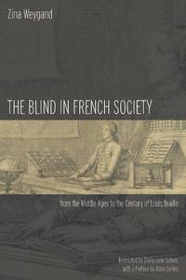
ZINA WEYGAND’S HISTORY OF THE BLIND IN FRANCE NOW AVAILABLE IN ENGLISH

Stanford University Press recently published DHA member Zina Weygand’s The Blind in French Society from the Middle Ages to the Century of Louis Braille. The integration of the blind into society has always meant taking on prejudices and inaccurate representations. Weygand's highly accessible anthropological and cultural history introduces us to both real and imaginary figures from the past, uncovering French attitudes towards the blind from the Middle Ages through the first half of the nineteenth century. Much of the book, however, centers on the eighteenth century, the enlightened age of Diderot's emblematic blind man and of the Institute for Blind Youth in Paris, founded by Valentin Haüy, the great benefactor of blind people.

CATHY KUDLICK INTERVIEWS HENRI-JACQUES STIKER – PART TWO

Henri-Jacques Stiker is the first scholar to attempt a global, sweeping history of disability from Greek times to the present. Trained in philosophy and anthropology, he has been the leading figure in disability studies in France since the publication of his important book Corps infirmes sociétés : Essais d'anthropologie historique in 1982. English-speaking readers know the second edition of this book as History of Disability published by University of Michigan in 1999. Among the dozen books he has authored, co-authored, and edited are studies of art, public policy, and theory, all related to disability, and most of the work grounded in history. Now retired after teaching at a number of universities in and around Paris, he epitomizes the French academic, full of enthusiasm and energy, trained in several languages and conversant with scholars in a variety of disciplines. He is warm and open to every kind of idea. He speaks slowly and deliberately, a fact that sometimes makes it easy to forget just how well he blends theoretical abstraction and practical knowledge of policy.

Kudlick interviewed him at his home on the edge of the Montparnasse neighborhood in Paris in February 2008. What follows is her transcription and translation of their ninety-minute talk. In Part I they discussed how he came to disability history and the changes he made to the third edition of Corps infirmes. In Part II they pick up with his thoughts on the state of disability history as a field in France, his current and future work, and his advice for young scholars.

CJK: What do you think of the current state of disability history in France?
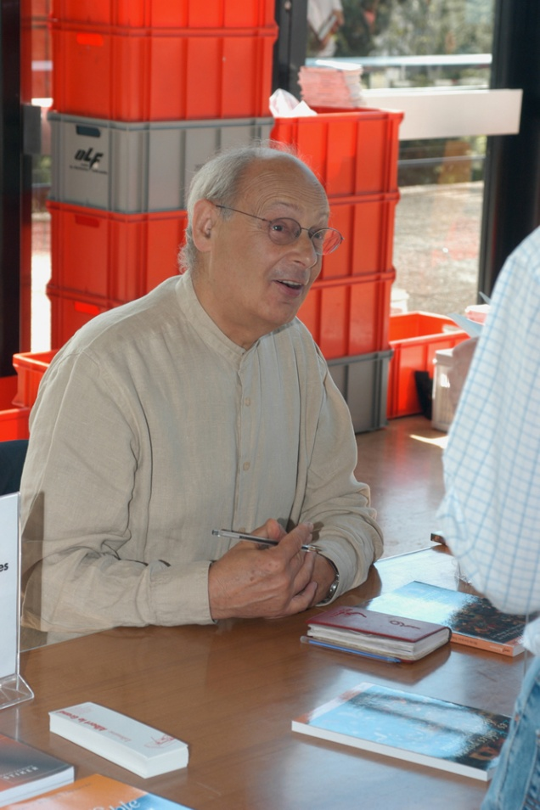
HJS: It’s just like disability in general; it’s not well recognized within history circles at the university. There are a few forays. There are books here and there, such as mine and the work of Jean-Christophe Coffin on the history of madness in the nineteenth century, so that makes him a kind of disability historian. And there’s Zina Weygand on blindness. There have been a few texts on the history of deafness such as Harlan Lane’s oriented toward history, which is an important book. And then there are snippets by people like Bernard Mottez, a sociologist, who is one of the leading theorists of deafness in France. He was a professor at the Ecole des Hautes Etudes en Sciences Sociales. Now he is retired and in poor health, so he doesn’t publish anymore. He isn’t a historian, but he’s interested in the historical aspects of deafness.

CJK: Is he deaf himself?

HJS: No, not at all. He came into the study of disability a little bit like me, through the humanities and social sciences, only occasionally in the beginning. But he was really taken with the communitarian cause and became quite militant.

CJK: A little like Harlan Lane, no?

HJS: Yes, he’s a kind of French Harlan Lane except that he’s less a historian. But his work did contain some history, a partial history of deafness.
But really, all this work is still very scattered. There’s no one place or person who says “my principal area of research is the history of disability.”

CJK: How do you explain this? You have Michel Foucault and Georges Canguilhem, and a number of others who deal directly with the subject, but not a single historian who says “I’m working on the history of disability.” Why?

HJS: I think this can be explained by two things. For one thing, the French university system and the goals of research are very much linked to disciplines. You have to be a sociologist, anthropologist, psychologist, etc. There are very precise criteria. When you touch on a topic such as disability, you are forced to be inter-disciplinary. So someone who wanted to present a thesis on disability would have to link it to a discipline, saying for example that it’s history - this was the case with Zina Weygand. But anyone who works in an interdisciplinary way would find little room in the French university, which is very, very structured around disciplines. There’s no discipline devoted solely to disability.

CJK: There’s history of medicine and history of science, which exist in France and fall outside of this disciplinary structure. . . .

HJS: This is true - there are historians of medicine and of science, in fact many of them. But there have never been any of disability.

CJK: So the second reason that there isn’t disability history in France?

HJS: The second reason is because the subject, if not completely marginal is unsettling. People are uncomfortable with the topic. So it’s better to concern themselves with Napoleonic Wars, agriculture, etc. I can’t find the right word, but it makes people uneasy, sometimes afraid. So to free themselves they claim it’s a question of technique, a topic for specialists, and that disabled people need help with living their lives. So theories of disability don’t interest them.
I say this because when I had a manuscript on art [and disability] that I wanted to send to the big publishing house Seuil, I got a letter back from the person in charge of art saying [essentially?] this very thing: that disabled people didn’t need someone creating a theory for them, and in the end they probably wouldn’t understand what people wrote about them anyway. Real disdain!

CJK: Goodness! You should have kept the letter!

HJS: It shows the mentality that exists.

CJK: And of course everyone knows there are no professors with disabilities, at least nobody that will admit it.

HJS: Well, there are a few, but really not many.

CJK: Of course I was kidding.

HJS: In my research institute [labo] we had a strange situation where I was immediately brought in by people such as Michelle Perrot who had been founders of women’s history. They had ratified women’s history as a subject in history against all odds. So they were sensitive to the fact that disability could also be listed as a historical subject. When she left, her successor had a serious accident that left him in a wheelchair. It was André Gueslin, a historian who studied poverty. This put him in a somewhat similar situation to that of [Robert] Murphy, who found himself knowing disability first-hand. So when he first arrived at the institute, he was running around like a rabbit. He is now sensitized, and yet he doesn’t do disability history, but rather the history of poverty in the nineteenth century.

CJK: Of course there were plenty of disabled people among the poor of the nineteenth century!

HJS: Well, we did lead seminars together. And there are other scholars at the university level with disabilities.

CJK: Yes, there’s Jacques Semelin [a blind professor at the Ecole des Hautes Etudes who now studies the history of genocide]

HJS: And others no longer here . . . . one who was a good friend of mine, Rene Claude Lachal who was [quadra?]plegic and a director of research at the CNRS. He was very good in Italian and did his thesis on disability in Italian literature. Today there is Jean-Francois Ravaud who had polio and is in a wheelchair. So a number of researchers and teachers with disabilities.

CJK: Even so there’s no real field of research.

HJS: The strange thing in France is that there are a number of fine studies in different fields, sociology, history, anthropology, some really good work. But there’s no ‘official position’ on the subject.

CJK: It’s the same with women’s history. You have a number of people studying the topic, but no real field of women’s history as there is in the UK and USA or the Scandinavian countries.

HJS: But of course there’s the publication of a major five-volume study on the history of women!

CJK: Yes. But what I mean is that there isn’t a field, a sense where students say “hey, we absolutely need to have someone who studies the history of women.”

HJS: It’s true, that there aren’t any chairs in Women’s Studies like there are in the USA.

CJK: Well, there aren’t hardly any for disability studies either.

HJS: But I’ve attended several meetings of the Society for Disability Studies where there are lots of participants, some of them even with positions in universities where they teach disability studies.

CJK: Yes, it it isn’t institutionalized in the same way. Take the example of my own career: I didn’t start into disability studies until after I’d gotten tenure. I didn’t really think about it because I was so caught up in writing my thesis on cholera epidemics that I didn’t even dare say even to myself that disability was something that might be interesting. In fact, I had no idea of what was going on in this field, that there was anything out there.
Now of course we have a whole younger generation - not as much among historians, but in literature and sociology - and hopefully before too long in history too, but it’s still going to require a bit of work!

HJS: Hmmm, I was thinking that your situation [in the USA] was a bit further along . . . .

CJK: Not really, unfortunately.

HJS: In France there’s an effort to create, to structure an area of research on disability, there’s a hope coming from the new law of 2005 on disabilities that envisions an entity focused on disability. The goal of this blue ribbon committee [observatoire] is to assess the current state of disability and to have proposals in three areas: prevention, professional development, and research. The research group, of which I’m a part, is devising a structure to facilitate research on disability, that is, setting up research groups, that specialize in this area or that are tied to larger groups that offer grants, to guide research in the social sciences: history, sociology, anthropology, social-psychology, etc., because medical research and genetics is fairly advanced, with labs and such. And in the technological realm there’s lots of work on prosthetics and other devices.

CJK: To move on to another topic: if you could pick any three books you know of in French that should be translated for historians who read English, what would they be?

HJS: Well, I won’t include mine, which has already been translated, or Zina Weygand’s [The Blind in French Society from the Middle Ages to the Time of Louis Braille, Stanford University Press, 2009] for the same reason . . . . [long pause] Well! Strange how hard it is for me to think of something!
Okay, the work of Bernard Mottez on deafness. There’s a recent collection of his essays called Les Sourds existent-ils? [Do the Deaf Exist? French ed., L’Harmattan, 2006] pitched to university-level readers. [more silence....]
There are some conference proceedings and edited collections, but they’re all pretty uneven - some really good work here and there . . . .
Ah! There’s the recent good book by Alain Blanc, Le Handicap ou le désordre des apparences [Disability or the Disorder of Appearances, French ed., Broché, 2006] He’s a sociology professor at the University of Grenoble.
And I think that within the American context that is .... Simone Sausse-Korff’s book, Le miroir brisé : L'Enfant handicapé, sa famille et le psychanalyste [The Broken Mirror: the Handicapped Child, Her Family, and the Psychoanalyst, French paperback ed., Hachette, 2009] It’s been out for awhile, but it’s a very good book.
Beyond that there are the books on special education that are good . . . .

CJK: But they’re pretty specialized because the French and American systems are so different, right?

HJS: Definitely.

CJK: Okay, to pose the question in the other direction: what English-language books on disability would you like to have translated into French?

HJS: Tom Shakespeare’s recent book, Disability Rights and Wrongs [Routledge, 2006].

CJK: What about for historians?

HJS: I’m afraid it’s your job to find books and ask that they be translated into French!

CJK: [Laughing] Okay. But I’m asking in the spirit of a trans-Atlantic dialogue.

HJS: For translating into French I just remembered the book Disability and Culture by Ingstad and White [University of California Press, 1995]. I think French readers would really benefit.

CJK: Another big question: what are you the most proud of in terms of your work?

HJS: I can’t respond to such a question . . . . I guess it would have to be Corps infirmes et sociétés [A History of Disability, Michigan, 2000] because it’s where I developed things to the fullest . . . . But I also like my book on art, Les fables peintes du corps abîmé : Les images de l'infirmité du XVIe au XXe siècle [Painted Fables of the Damaged Body: Images of Infirmity from the Sixteenth to Twentieth Century, French ed., Broché, 2006] because I think it’s an original point of view that has never been developed like this before. I know that people like [David] Mitchell and [Sharon] Snyder have worked on art, so I’m far from alone. But to have put forth a far-reaching hypothesis like this about painting. Yes, it’s this that I like most of all that I’ve done.

CJK: What are you working on now?

HJS: I have a book that’s about to come out, which is focused on questions about disability in France over the past forty years. [Les métamorphoses du handicap de 1970 à nos jours : Soi_même, avec les autres (Broché, 2009)] The big questions of what’s at stake can be applied maybe not universally, but certainly well beyond France. But because I was asked to write about this in the French context, all my examples of laws, of events, are French examples, so I don’t think it’s exportable. Even though questions of suffering, questions of creating distance from the Other, questions of laws of compensation, so many questions, discussions of concepts and theories, all these are things that reach beyond France. But the book still isn’t really transferable.
I’m working on another project that I think would translate much more easily, that is to take up the question of disability within religions. I’ve done [in A History of Disability] a chapter on the Jews, on Christianity, the birth of Christianity, evangelicalism, which means I’ve already written something about it. But I really want to develop the perspective that religion has on disability. That would be of interest well beyond France.

CJK: Have you started?

HJS; No, not really, but I have things in mind. It’s going to require a lot of work.

CJK: Oh, but this would be a huge benefit to the field!

HJS: The problem when you write about disability is that you’re always working from within a specific context. You take your examples, etc., from around you. As a result, a German, Englishman, an American, a Japanese won’t be inspired. So you have to find subjects [with broad appeal.] I could maybe write a short book of a hundred pages or so about what are mostly universal issues. For the past century there are things that apply more or less everywhere. So I might do that too.

CJK: You’re doing a lot!

HJS: Yes. And I’m working on a number of articles too. For example I’m writing something now for Ethnologie française, which is a prestigious journal, where I’m taking up the subject of the anthropology of designations and classifications, which is also something that could be translated. Articles such as these could be part of a collection . . . . But really, I’d like to write a whole book on the subject of anthropology of disability in the major religions.

CJK: So now you’re retired. . . .

HJS: Yes, I’m retired. But since I’m associated with the research institute called “Identity, Culture, Territory,” there’s no fixed retirement date. And there’s no fixed date because I’m not paid. So everything runs well because I’m there and not costing them a penny.

CJK: So you travel a lot? And you give lots of talks....

HJS: Oh yes. Not too much outside of France but from time to time to Belgium, to Switzerland. I used to go to Quebec, but not so much any more.

CJK: Do you give advice for young scholars who are just entering the field?

HJS: Oh yes! There are a fair number of them, and they all come to me for advice. There’s a little germination process happening, a little harvest. Last week a young woman from Brittany got in touch and we spent a couple of hours at a bistro waiting for a train. She asked me for advice about how to pick a dissertation director, how to develop a dissertation, things like that.

CJK: So do you have advice for new researchers?

HJS: Well, a number of things. First, you need to have broad cultural knowledge. So for example, if you’re going to study disability in the middle ages, you have to steep yourself in the literature and philosophy of the time. You should not limit yourself to what is strictly related to disability. You have to get at what everyone is thinking about in a certain time: human relations, their relationship to divinity, with nature. You have to study culture because often disability can be found within these general elements of a culture.
At least for now, don’t expect to make a career today out of [doing] disability [history]. [laughter] Unless, you have a university career that follows a conventional path like the young graduates of the École Normale Supérieure In other words, link yourself up with a real discipline.

CJK: That seems like very good advice! Members of the Disability History Association will find it useful. Thank you.

HJS: You’re very welcome.

Fin

