2023 Disability History Association Annual Report

2023 Disability History Association Annual Report 1
Past President’s Message 2
Governance 2
Fundraising and Development 3
Communications 3
Partnerships 3
Programming 4
Awards 4
Podcast 5
All of Us 5
Internships 6
Gratitude 7
Addenda 8
Annual Financial Report (2023) 8
Statement of Position 8
Statement of Activities 8
Statement of Activities as Compared to 2023 Budget 10
Statement of Cash Flows 11
Disability History Association Conflict of Interest Policy 13
Purpose & Overview 13
Award Ineligibility 14
Statement of Conflict of Interest 14

Past President’s Message

In the spring of 2022, the Board of Directors started two lists. The first was devoted to naming the people whose creativity and generosity, particularly since 2020, had allowed the DHA to become. The second became a repository of hope, a space to hold the futures we imagined for the DHA. Both documents continue to reside in the DHA’s informal archive.

As mundane tools for remembering, these lists epitomize the ordinary and the uneventful in the life of our organization. But they also represent the work of governance in which the Board of Directors quietly engages: determining a present course of action that mediates between the past and the present, between what the DHA has been and what it might yet become.

This work seems particularly apt now, as 2024 marks the 20th anniversary of the DHA’s inaugural board meeting. There is so much to celebrate. The pages that follow — showcasing the extraordinary creativity of our members, interns, committees, and directors — are evidence of that abundance. The DHA, thanks to all of us, is strong.

- Katheen Brian, former Disability History Association President

Governance

Welcomed Katie Healey as its first Director of Media and Accessibility.

Welcomed Marco Di Giulio as its inaugural Director of Development.

Welcomed Jenifer Barclay as its new Director of Awards.

Welcomed Sarah Handley-Cousins (Director of Records) as its interim President.

Established a Governance Committee, led by Director Nicole Belolan. Committee members include Laurel Daen (Treasurer), Elliott Simon, Eric Deutsch, and pete marshall. The Governance Committee hosted three conversations about identifying a new president and the future of the DHA. A report will be shared.

Completed an annual self-assessment, led by Director Nicole Belolan. Some key takeaways: Board members feel their opinions are valued, and we hope to continue to increase our transparency by posting our financial snapshots to our website, creating a new governance section on our website, and reporting back to our members more frequently.

Approved a conflict of interest policy. See page 9.

Fundraising and Development

Initiated research into new revenue streams from prospective funders, led by Director Marco Di Giulio, the Board.

Added a button to the website for one-time donations, led by Director Katie Healey

Communications

Re-launched a quarterly newsletter, led by Director Jiya Pandya.

Initiated website reorganization, led by Director Katie Healey.

Partnerships

Announced a new prize in partnership with the University of Illinois Press’s Disability Histories series. The Outstanding Dissertation in Disability History prize will be awarded annually, beginning in 2023, to recognize and reward exceptional work in disability history done by early-career scholars. This year’s winner: Katherine Ranum, “Hearing the Gospel in a Silent World: Faith, Disability, and Anomalous Bodies in the British Atlantic, 1680-1860.”

Programming

Hosted Susan Burch and Kim Nielsen for a workshop on letters of recommendation, led by Director Kristen Nassif. Thirty members registered for the workshop.

Hosted ten sessions of the Disability History Graduate Writing Workshop (DHGWW), serving about 16 students over the academic year (2022-2023). Led by Director Jasper Conner.

Formed an exploratory committee to research the possibility of holding a disability history conference, led by Directors Kristen Nassif, Jiya Pandya, and Jasper Conner.

Awards

Led by several award chairs, teams of committee members awarded the following accolades:

Outstanding Book Award: Wei Yu Wayne Tan was declared the winner for Blind in Early Modern Japan: Disability, Medicine, and Identity (University of Michigan Press, 2022).

Outstanding Book Honorable Mention: Alexandre Sumpf was awarded the honorable mention for The Broken Years: Russia’s Disabled War Veterans, 1904-1921 (Cambridge University Press, 2022).

Inaugural Research for Justice and Equity Award: Nandana R for “Between the Politics of Pain and Care: Studying the Public Discourse of Disability in Kasargod-Endosulfan Episode.”

Outstanding Chapter or Book Award: Jonathyne Briggs as the winner for his article "From Collaboration to Resistance: The Family Dynamic in Autism Literature in Contemporary France," published in Contemporary European History.

Outstanding Chapter or Book Award Honorable Mention: Michael Rembis, "We Had Very Good Times Together: A Mad People's History of Life on Asylum Wards in the Early Twentieth Century United States," published in Studies in Contemporary History.

Podcast

Led by podcast team Kelsey Henry and Katie Healey (and Caroline Lieffers, who left the Board in early 2023), published four episodes in 2023 and recorded two episodes that will be published in 2024. Four interviews are currently scheduled, to take place in 2024. The podcast team is researching ways to count listeners and/or viewers of podcast episodes. All podcast episodes can be viewed here: https://dishist.org/?page_id=735.

Sami Schalk and Guest Host Emma Wathen, "Black Disability Politics," January 2023.

Dr. Maria Bucur, Dr. Frances Bernstein, Dr. Maria Cristina Galmarini, and Dr. Magdalena Zdrodowska, With Guest Host Isabelle Avakumovic-Pointon, "Disability History in Eastern Europe: A Roundtable Discussion, March 2023.

Sandy Sufian, “Adoption, Risk, and the Modern American Family,” July 2023.

Allison C. Carey, “Allyship, Parent Activism, and Disability Rights,” October 2023.

All of Us

Welcomed editorial board members Sarah Handley-Cousins, Jenifer Barclay, and Jiya Pandya, who are also on the DHA Board. Director Stefanie Hunt-Kennedy leads the blog team and is assisted by Jenny Reiss as Managing Editor and Sam Burnett as Layout Editor.

Esme Cleall, “Kitto’s Conundrum: Disability, Writing And Identity,” December 10, 2023, https://allofusdha.org/research/kittos-conundrum-disability-writing-and-identity/.

Kim Nielsen and Susan Burch, “Some Recommendations on Letters of Recommendation,” November 1, 2023, https://allofusdha.org/reflections/some-recommendations-on-letters-of-recommendation/.

Wulf Scouller, “Restraining Confinement in Early America,” September 17, 2023, http://allofusdha.org/research/restraining-confinement-in-early-america/.

Meg Roberts, “#ClappingForCarers in 1776: the American Revolutionary War and Covid-19,” August 21, 203, http://allofusdha.org/reflections/clappingforcarers-in-1776-the-american-revolutionary-war-and-covid-19/.

Jemma Lakmaker, “Disability: Pedagogy and Identity in the Classroom,” June 6, 2023, http://allofusdha.org/research/disability-pedagogy-and-identity-in-the-classroom/.

Sam Brady, “Showcasing athletes’ experiences through a Paralympic history tour app,” May 12, 2023, http://allofusdha.org/research/showcasing-athletes-experiences-through-a-paralympic-history-tour-app/.

Laurel Daen and Marianne Petit, “Mouth & Toes: The World of Nineteenth-Century Silhouette Artists with Disabilities,” February 1, 2023, http://allofusdha.org/research/mouth-toes-the-world-of-nineteenth-century-silhouette-artists-with-disabilities/.

Internships

Formalized the DHA’s internships program (led by Director Kristen Nassif).

Gratitude

We said farewell to DHA President Kathleen Brian. Katie devoted 10 years of service to the DHA. Thank you, Katie!

The current directors would also like to honor the extraordinary contributions of Directors who have stepped down from the Board since 2020:

Iain Hutchison
Caroline Lieffers
Aparna Nair
Sara Scalenghe
Wayne Tan
Jaipreet Virdi

Addenda

Annual Financial Report (2023)
Prepared by Laurel Daen, Treasurer

Statement of Position

Also known as a balance sheet, this report shows the DHA’s assets and liabilities at the close of the calendar year (12/31/23).
Assets
- PayPal | $4,749.91
- Umpqua Checking | $7,801.38
- Umpqua Savings | $500.31
Total: | $13,051.60

Liabilities
None

Statement of Activities

Also known as an income statement, this report shows the DHA’s revenue and expenses for a specific time period (1/1/23-12/31/23).
Revenue
- Membership Dues and Donations | $4,390.00
Expenses
Awards
- Conference | $500.00
- Book | $300.00
- Article | $200.00
- Justice and Equity | $500.00
Awards Total | $1,500.00
Website
- Domain Renewals | $110.00
- PayPal Renewal | $39.00
- PayPal Fees | $162.18
Website Total | $311.18
Programming
- Letters of Rec Workshop | $700.00
- Listening Sessions | $1,039.00
Programming Total | $1,739.00
Miscellaneous
- Tax Registration | $25.00
- One Pro-rated Membership Return | $15.00
Miscellaneous Total | $40.00
Total | $3,590.18
Cash extra | $799.82

Statement of Activities as Compared to 2023 Budget

Actual Expenses (2023) |  |  | DHA Budget (2023)
Revenue |  |  | Revenue
Membership Dues | $4,390.00 |  | Membership Dues | $2,823.93
Expenses |  |  | Expenses
Awards | $1,500.00 |  | Awards | $2,200.00
Website | $311.18 |  | Website | $189.62
Podcast Transcription | $0 |  | Podcast Transcription | $200.00
Programming | $1,739.00 |  | Programming | $200.00
Miscellaneous | $40.00 |  | Miscellaneous | $0
Total | $3,590.18 |  | Total | $2,789.62
Cash extra | $799.82 |  | Cash extra | $34.32

Statement of Cash Flows
This report shows cash inflows and outflows for a specific time period (1/1/23-12/31/23).
(Next page).
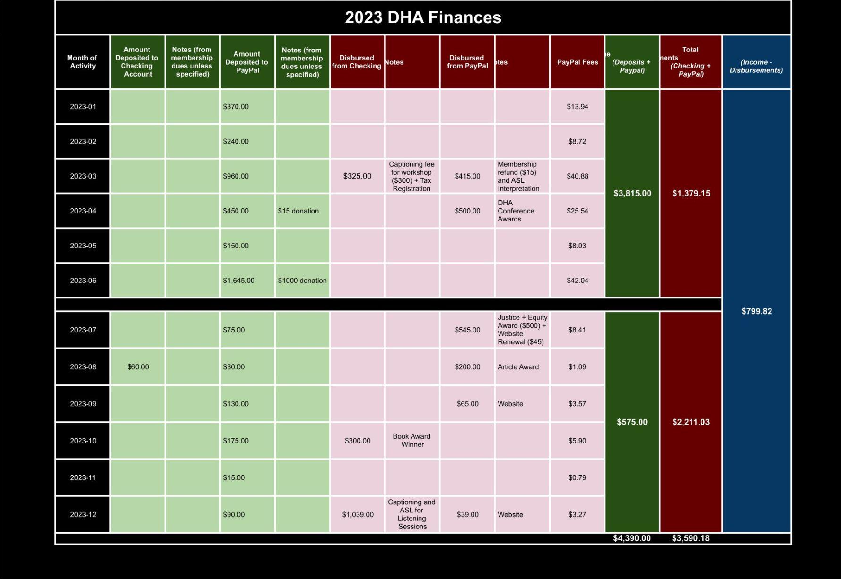

Disability History Association Conflict of Interest Policy

Disability History Association . Board of Directors
Conflict of Interest Form

Purpose & Overview
The Conflict of Interest Form is an acknowledgement of the Board of Directors’ fiduciary duty to the Disability History Association (DHA) and its patrons. As an agent and trustee for the DHA, each individual Director is charged with:

- informing themselves, before rendering a decision, through the critical assessment of all known and relevant information (duty of care).
- acting in the best interest of the DHA, even when this conflicts or may conflict with an individual’s private interest (duty of loyalty).
- acting in accordance with the law (duty of good faith).
- maintaining the confidentiality of information that should not be disclosed (duty of confidentiality).
- using care, skill, and caution in the decision-making process (duty of prudence).
- acting with complete candor, including a willingness to disclose all relevant information related to a decision made on behalf of the DHA (duty of disclosure).
In addition to completing the Director Agreement and an initial Conflict of Interest Form, voting members of the Board of Directors are responsible for updating their Conflict of Interest Forms as necessary for the duration of their three-year tenure. The Board will help Directors determine where the conflict requires any action. When completing the Conflict of Interest Form, Directors should account for any relationship or situation that has even the appearance of conflict. If any at any time a Director would like to resign from the DHA Board to pursue an opportunity they would be precluded from due to a conflict with their duties as a DHA Director, they are welcomed to do so and will be warmly acknowledged for their service .

What to disclose in terms of potential conflicts of interest might include but is not limited to:

(1) your affiliations with any organization with which the DHA may have a financial relationship, and

(2) persons with whom you have a close relationship (such as a family member or close companion) who are affiliated with any organization with which the DHA may have a financial relationship.

Award Ineligibility
In addition to requiring that incoming directors complete the Director Agreement and an initial Conflict of Interest Form, it is DHA policy that members of the Board of Directors are ineligible for awards sponsored or co-sponsored, whether monetarily or nominally, by the DHA. This is designed to eliminate, to the extent possible, actual and perceived conflicts of interest that may arise during the selection of awardees and the distribution of award monies. Ineligibility continues for six months after an individual has stepped down from a Board position. Exceptions may be considered by the Board and made on a case by case basis.

Statement of Conflict of Interest

As a voting member of the Disability History Association’s Board of Directors, I assert that:

- I have read and understood, and will abide by, the policy described above. I will notify the Board immediately if a new and/or anticipated conflict arises.

As a voting member of the Disability History Association’s Board of Directors, I assert that:
- I currently do not have any conflicts of interest that may prohibit me from fulfilling my fiduciary duty in all matters.

- I currently have one or more conflicts of interest, described in the attached document, that may prohibit me from fulfilling my fiduciary duty in some matters. I have attached a brief narrative explanation and agree to abide by Board decisions regarding procedure in such instances.

Name: ＿＿＿＿＿＿＿＿＿＿＿＿＿＿＿＿＿＿＿＿＿＿＿＿＿＿＿＿＿＿＿＿＿＿＿＿＿＿
Date: ＿＿＿＿＿＿＿＿＿＿＿＿＿＿＿＿＿＿＿＿＿＿＿＿＿＿＿＿＿＿＿＿＿＿＿＿＿＿＿

Signature: ＿＿＿＿＿＿＿＿＿＿＿＿＿＿＿＿＿＿＿＿＿＿＿＿＿＿＿＿＿＿＿＿＿＿＿＿＿

