SPRING 2015 DHA Newsletter
© Disability History Association

2 MESSAGE FROM THE EDITOR
Penny Richards

3 ANNOUNCEMENTS

9 UPCOMING CONFERENCES
10 ‘Come to the Dark Side: Disability as “Dark” Civil War History’
Sarah Handley Cousins

14 ‘Supporting Disability in Cambodia’
Iain Hutchison

MESSAGE FROM THE EDITOR
Penny L. Richards

WELCOME!

Perhaps appropriately for springtime, this issue of the newsletter is full of reports of what’s new and blossoming in the world of disability history: new exhibits, new archival efforts, new scholars. Be sure to check out the winners of this year’s DHA Graduate Student Awards, and the survey from the Disability History/Archives Consortium, a new group that needs your input. And speaking of needing your input…

If you have a moment, would you contact DHA President Sandy Sufian at (sufians@uic.edu) and let DHA know if you have any suggestions for improvements, especially with regard to activities or programs? We, the DHA Board of Directors, are striving to find new ways to promote disability history and would be very appreciative of your feedback.

Have you renewed your DHA membership for 2015? Please consider doing that right now, while you’re enjoying the newsletter, it won’t take but a moment. And if you already have your membership, perhaps make a surprise gift to a colleague or student?
http://www.dishist.org/join.htm

ANNOUNCEMENTS

We’re delighted to announce three winners this year for the Graduate Student Awards:

Rabia Belt (doctoral candidate, U-Michigan, US), gave a paper entitled, “Ballots for Bullets: Disabled Civil War Veterans and the Right to Vote;” she also presented on a roundtable on the state of the field of disability history at the Organization of American Historians conference in St. Louis, Missouri (US) in April.

Haley Gienow-McConnell (doctoral candidate, York University, Toronto, CA) will present a paper entitled “Representations of Historical Disability on The Waltons, 1936-1945, 1972-1981,” at the "Rethinking Disability on Screen Symposium” in York, UK in May.

Mary Mendoza (doctoral candidate, UC-Davis, US) will be giving a presentation entitled “La Tierra Pica/The Soil Bites: Hazardous Environments and the Degeneration of Bracero Health, 1942-64” at the Society for Disability Studies conference in Atlanta, Georgia (US) this June.

Congratulations to all three fine students. We can look forward to reading more about each awardee’s work and travels in future issues of the DHA Newsletter.

“Patient No More: People with Disabilities Securing Civil Rights" exhibit in Berkeley, July-December 2015

(from Catherine Kudlick, Professor of History and Director, Paul K. Longmore Institute on Disability, San Francisco State University)

Fellow disability historians, if you’re in the San Francisco Bay Area this fall, come check out the Paul K. Longmore Institute on Disability at San Francisco State University’s exhibit “Patient No More.” It will launch at the Ed Roberts Campus above Ashby BART in Berkeley on July 26, and will be there until December 18. We also have a traveling exhibit and a website.

Timed to coincide with the 25th anniversary of the Americans with Disabilities Act (ADA) this July, “Patient No More” focuses on the month-long occupation of San Francisco’s Federal Building by more than one hundred people with disabilities in April 1977. Four years earlier, Section 504 of the Rehabilitation Act of 1973 had made it illegal for any federally-funded facilities or programs to discriminate against disabled people. One signature from the Head of Health Education and Welfare (HEW) stood in the way of the law taking effect. People waited. At last in 1977 frustration turned into bold action. A diverse coalition launched protests across the country. San Francisco's occupation was the largest and longest. Over 100 people refused to leave HEW's regional office until the 504 regulations were signed without any changes. The protesters were successful, and Section 504 would serve as a blueprint for the ADA.

We’re especially excited about the built-in accessibility features that in many ways determined not just our presentation but some of our content; this goes against the usual practice of adding such features at the end. And we have amazing oral histories conducted by journalism and history students at San Francisco State.

We’re planning an opening reception on July 26 that will bring together many of the occupiers and supporters - plan on joining us for an amazing reunion.

To learn more, visit our website PatientNoMore.org that will be live by the end of May. Or visit the Longmore Institute webpage: LongmoreInstitute.sfsu.edu

H-Disability Book Reviews

(from Iain Hutchison, H-Disability reviews editor)

The Disability History Association and H-Disability have now been active for a few years in bringing reviews of books related to our discipline to a discerning audience.

To existing reviewers, we invite you to update you areas of interest if you feel that we may be working from an out-of-date profile. If you are on our list but have not yet reviewed, or have not reviewed for some time, please free to advise us of any recent book that you might like to review and we will endeavour to acquire a review copy.

If you have not registered as a reviewer, but would like to, please email and introduce yourself. We are always keen to make contact with reviewers that we know we can rely upon. We need to know:

- Your name, affiliation and contact details.
- Your postal address for mailing books.
- Your areas of interest and expertise, such as aspects and areas of disablement; geographical scope; time period.

Reviews must be in English, but if you can read works in other languages, that is of interest to us. Indeed, for DHA to have a truly global spread, we encourage material and expertise that extends beyond the western Anglophone world.

To authors, if you have published a book on aspects of disability and the history of disability within the last couple of years, and would like your work to be reviewed on H-Disability, please get in touch. The following information will be helpful: name(s) of author(s) or editor(s); title of book; name and location of publisher with year of publication; and the ISBN. Please let your publisher know that you want your work to be reviewed by H-Disability.

I look forward to hearing from you.
iain.hutchison@glasgow.ac.uk

Upcoming Library Company of Philadelphia Multi-Sensory Exhibition Explores the Nature of Perception
(from Erika Piola, Co-Director, Visual Culture Program, Library Company of Philadelphia)

The Library Company of Philadelphia is pleased to announce our collaboration with artist-in-residence Teresa Jaynes on Common Touch, a multimedia exhibition generously funded by The Pew Center for Arts & Heritage. The exhibition, developed under the auspices of the Library’s Visual Culture Program, will explore historical embossed and raised-letter documents for the visually impaired as a starting point for a multi-sensory exploration of the nature of perception. Jaynes is advised by her Vision Council, professionals in the fields of education, arts, culture, and accessibility who have experienced variable degrees of vision loss during their life, as well as project partners, including Art-Reach (Philadelphia), the Institute on Disabilities at Temple University, and the Monell Chemical Senses Center.

Jaynes, an installation and book artist, uses literature, visual material, and artifacts to create works with a historical context that are both engaging and thought provoking. Raised-printed texts and ephemera; nineteenth-century personal narratives authored by the blind; and reports, pamphlets, and magazines issued by educational institutions for the blind comprise some of the numerous holdings at the Library Company that document the lives of people with disabilities during the long nineteenth century that will be displayed alongside contemporary artwork by Jaynes. These diverse materials related to the history of the education of the blind will inform the conceptualization of the themes of Common Touch, which will open at the Library Company in April 2016. To create a community dialogue about the project, the Common Touch website with corresponding social media will go live by summer 2015. Website content and posts will highlight the progress of the project, relevant Library collection items, project partners’ news, as well as explore the compelling interrelationships between art, disability studies, and historical collections.

For further information about Common Touch, please contact Erika Piola at epiola@librarycompany.org.
Library Company of Philadelphia
1314 Locust Street, Philadelphia, Pa. 19107
epiola@librarycompany.org
215-546-8229
Ward M. Canaday Center at the University of Toledo continues to expand collections documenting disability history

(from Barbara Floyd, director, Ward M. Canaday Center for Special Collections, The University of Toledo)

The Regional Disability History Archives of the Ward M. Canaday Center at the University of Toledo has continued to expand its collecting in concert with the expansion of UT’s Disability Studies Program. Both the program and the archives were created in 2001. The Canaday Center disability history collections initially focused on documenting disability regionally in northwest Ohio, but in more recent years the Center has begun to expand its focus nationally.

At the national level, the Canaday Center recently supplemented its collection of personal papers from Hugh Gregory Gallagher with a small collection documenting one of Gallagher’s disability rights activities. In 1998, the National Organization on Disability and the National Parks Service convened a group of disability scholars and charged the group with finding an appropriate quote that could be added to the Roosevelt Memorial on the mall in Washington, D.C. near the new statue of Roosevelt depicting him seated in a wheelchair. The committee was chaired by Scott Sandage, a professor of History at Carnegie-Mellon University in Pittsburgh.

The addition of the seated Roosevelt to the memorial was a controversial one, and Hugh Gallagher had been one of its biggest advocates. Gallagher, whose extensive personal papers are preserved in the Canaday Center, had studied Roosevelt for his book FDR’s Splendid Deception. Gallagher’s thesis contended that Roosevelt had hid his disability from the public. When the Roosevelt memorial opened without any depiction of the president in a wheelchair, many disability advocates, including Gallagher, felt that this was yet another attempt to deceive the public about Roosevelt’s disability.

After the statue of Roosevelt in a wheelchair was added to the memorial, the NOD and the National Parks sought input into an inscription to accompany the statue that would summarize Roosevelt’s views on disability. The deliberations of the committee appointed to recommend the inscription in many ways encapsulated the arguments of disability historians regarding Roosevelt’s role in history.

The collection was donated to the Canaday Center by Sandage. It, and the personal papers of Gallagher, are preserved and available to patrons in the Canaday Center. Both the inscription committee files and the Gallagher personal papers are fully processed and accessible to researchers. The finding aids are available at: http://www.utoledo.edu/library/canaday/HTML_findingaids/MSS-277.html; and http://www.utoledo.edu/library/canaday/HTML_findingaids/MSS-185.html

On the local level, the Canaday Center recently acquired the records of the Toledo Hearing and Speech Center, an organization that had a nearly 100 year history before it closed last year. The records document the organization back to its founding in 1915 by Toledoan Bessie Anderson Dewey. Dewey, who herself was hearing impaired, realized that there were few services available in the city to help the hearing impaired.

The organization was officially established in 1919 as the Toledo League for the Hard of Hearing. In the 1960s, the name changed to the Toledo Hearing and Speech Center. It continued to provide vital services to Toledo’s hearing impaired until 2014, when it was forced to close its doors due to financial constraints.

The records of the center include administrative files dating back to its founding, the organization’s newsletter and other publications, photographs, and scrapbooks. The collection is fully processed, and is available to researchers. A finding aid is available at: http://www.utoledo.edu/library/canaday/HTML_findingaids/MSS-292.html

For more information on the Canaday Center’s disability history collection, please contact Barbara Floyd, director, at Barbara.floyd@utoledo.edu.

Disability History Archives Survey

(from Catherine Kudlick)

A planning committee of individuals from 15 organizations with an interest in disability history and archives met in February 2015 in Berkeley, California, at the invitation of the Bancroft Library. Those attending agreed to form a new organization of repositories interested in collecting, preserving, and making available archival materials documenting the history of disability.
During those deliberations, it became clear that disability documentation is broadly dispersed and often difficult to discover and access. Beyond the creation of an disability history/archives organization, we see the creation of a central portal as vital to improving access and discovery. Other projects, including cataloging, digitization and digital humanities, are sure to follow.
An immediate outcome of our meeting was a mission and vision statement:
MISSION: The Disability History/Archives Consortium is a national collaboration between educational institutions, libraries, and cultural heritage organizations that promotes the integration of collections, preservation, access, and the development of educational resources about disability history, broadly defined.
VISION: The Disability History/Archives Consortium will foster learning and scholarship by developing and sustaining an online portal to disability history.
The consortium’s planning committee is conducting a brief survey to determine the scope of disability-related collections currently available nationally. The committee is also attempting to the gauge the interest of other repositories in joining with us to plan for this national consortium dedicated to this effort.
We would greatly appreciate you filling out the survey or forwarding it to someone in your organization who can complete it. There are only ten questions and it should take about 5-10 minutes to complete. They ask whether you have disability collections in your organization, their estimated size, dates covered, scope, and your interest in collecting and cataloging them.
We look forward to hearing from you by no later than Friday, May 29, 2015.
Click on the link or button to begin the survey:
https://www.surveymonkey.com/s/RZ3B5ZB

New Audio Version of Greene’s “The Blind Brother” (1886)
Librivox just added an audio version of an 1886 book for younger readers, "The Blind Brother" by Homer Greene (1853-1940), that may be of interest to disability historians. (Note that Librivox recordings are made by volunteers and will vary in quality.) Here's the blurb:
The Blind Brother
Homer GREENE (1853 - 1940)
This is the first book written by Homer Greene, whose primary occupation was lawyer. It tells of 14-year-old Tom Taylor, and his 12-year-old blind brother Bennie, who work in the Pennsylvania coal mines in the late 1800s, earning money for an operation for the younger lad. A story of strikes and mine "falls" (cave-ins) along the way. - Summary by Donald Cummings
Genre(s): Children's Fiction
Language: English
https://librivox.org/the-blind-brother-by-homer-greene/

Exhibit: From Pit Head to Sickbed and Beyond (National Waterfront Museum, Swansea, Wales, 20 June–4 October 2015)
http://www.museumwales.ac.uk/swansea/whatson/?id=7909
“This exhibition will explore how disabled people were treated and viewed in the mining industry and the south Wales communities that relied on it.”
UPCOMING CONFERENCES
2-4 June 2015, Ottawa, Ontario, Canada
Canadian Disability Studies Association/Association Canadienne des Études sur l'Incapacité
http://www.cdsa-acei.ca/home.html
10-13 June 2015, Atlanta, Georgia, USA
Society for Disability Studies
http://disstudies.org/conferences/schedule_detailed
30 June 2015, University of Wales
Conference: Prostheses in Antiquity
http://www.disabilitystudiesnetwork.gla.ac.uk/2014/10/01/cfp-prostheses-in-antiquity-university-of-wales-trinity-saint-david/
2-3 July 2015, Paris, France
Annual meeting, ALTER (European Society for Disability Research / Société Européenne de Recherche sur le Handicap)
http://www.alter-asso.org/index.php?option=com_content&task=view&id=15&Itemid=24&lang=en
16-18 July 2015, Riverside, California, USA
Comics and Medicine: Spaces of Care
http://www.graphicmedicine.org/comics-and-medicine-conferences/2015-riverside-conference/
10-12 August 2015, Monash University, Melbourne, Australia
Translating Pain: An International Forum on Language, Text and Suffering
http://artsonline.monash.edu.au/acjc/call-for-papers-translating-pain-an-international-forum-on-language-text-and-suffering/
3-5 December 2015, Columbia University, New York, USA
The Politics of Memory: Victimization, Violence and Contested Narratives of the Past
http://www.humanrightscolumbia.org/?q=ahda/conference

Come to the Dark Side:
Disability as “Dark” Civil War History

Sarah Handley Cousins

(Originally published at the blog Nursing Clio on January 27, 2015
http://nursingclio.org/2015/01/27/come-to-the-dark-side-disability-as-dark-civil-war-history/
Reprinted in the DHA Newsletter with kind permission from the author. The original version had several photographs to illustrate the article; these were removed mainly for simplicity of layout, and can be viewed at the link above.)

Sarah Handley Cousins is a doctoral student in the History Department of University at Buffalo.

While the rest of the world was happily decking the halls and calling for goodwill toward men, Civil War historians — in the now-famous words of Historista blogger and historian Megan Kate Nelson — were “freaking out.”

They weren’t freaking out because of the discovery of some great new source material, or an exciting new publication. They were freaking out because both Civil War History and The Journal of the Civil War Era, the two major journals in the field, each published an article in their December issues that criticized the state of current Civil War research and writing. The major concern for the articles’ authors — Gary Gallagher and Kathryn Shively Meier for JCWE and Earl J. Hess for CWH — was that Civil War military historians, already a dying breed, are being hurried to their demise by eager social and cultural historians who dismiss military history as unscholarly and old-fashioned. Earl Hess suggests that “understanding the real battlefield of 1861-1865 is essential to understanding everything else about the Civil War.”[1] Gallagher and Meier assert that “because the Civil War was a massive war, every scholar of the conflict should be at least basically versed in its military history.”[2]

Like many others who have responded to these articles, I don’t disagree with these arguments. As Megan Kate Nelson stated, “of course logistics and strategy and the lived experience of combat are important. They were important to Civil War Americans, and so they are important to those who study them.” I also think it’s essential for historians of the era to know military terms — there’s a significant difference, for example, between a regiment and a brigade, a smoothbore musket and a rifle, infantry and cavalry. When I’m researching a veteran, it’s important that I understand what it means when he refers to the Crater, or Little Round Top, or Fort Pillow. These events were incredibly important to the soldiers who experienced them, even decades after the war’s end.

This plea for the preservation of military history isn’t what caused the uproar. Instead, it was the authors’ frustration with social and cultural history, or “war studies,” which have helped bring the experiences of women, children, blacks, and Native Americans into the study of the war era. That’s a good thing. But in addition to broadening the field, the authors suggest that these historians, probably influenced by the conflicts in Iraq and Afghanistan, take an anti-war stance in their work, making traditional military history unpopular inside the academy. An important aspect of this turn — and the one that raises the most ire with Gallagher, Meier, and Hess — is a move toward so-called “dark history,” which focuses on the disturbing and less glorious aspects of the war. In recent years, historians of the “dark side” have challenged our beliefs about the realities of emancipation for freedpeople and reminded us of the rape and torture perpetrated by Confederate and Union soldiers alike. Others — myself included — have started to investigate the lives of Civil War veterans, particularly those with physical and mental wounds. This, at least according to the defenders of military history, is “marginal” work that is at best misleading and at worst, presentist and ahistorical. As Gallagher and Meier put it, “the analytic risk of overemphasizing the dark side is that readers who do not know much about the war might infer that atypical experiences were in fact normative ones.”[3]

Aside from making many jokes about who was on “dark side” or the “light side,” as if we were participants in an epic galactic war, the historians of the Civil War blogosphere have rightly pushed back against many of these claims. I loved the Tattooed Professor Kevin Gannon’s argument that calling certain wartime activities “dark” means arguing that the rest of the activities were “light” — that the “purposeful extinguishing of another human life, and the constant impetus to do so repeatedly, was not dark.” But one issue that hasn’t been yet raised is how disability figures into this debate. According to this critique of war studies, war-related disabilities were not a typical experience, and those who did have disabilities were able to “overcome” in order to lead successful civilian lives. This interpretation relies on a surprisingly outdated understanding of disability and disability history. The history of disabled people in the United States has long been considered marginal, often on the grounds that it does not represent the experiences of society as a whole, but rather isolated, personal, medical issues. Yet Douglas Baynton explained over a decade ago that disability history is about more than pointing out that disabled people existed. Just as Joan Scott proposed that we use gender as a lens in the 1970s, Baynton argued that disability is critical to interpreting society and culture. “Disability,” he stated, is not as simple as individual medical problems, but “a fundamental element in cultural signification and indispensable for any historian seeking to make sense of the past.”[4]

This seems especially true in the study of the Civil War, or for that matter, any war. As Elaine Scarry has noted, “the main purpose and outcome of war is injuring.”[5] The central aim of having hundreds of thousands of heavily armed men line up and shoot at each other is to inflict bodily harm. And when these men weren’t actively shooting at each other, they were living on poor rations and bad water, sleeping and marching in all kinds of weather, generally far from familiar environments, climates, and loved ones — all of which wreaked havoc on their bodies and minds. Soldiers routinely described themselves to be “worn out” or “used up” by the stresses of war. When the Surgeon General’s office published The Medical and Surgical History of the War of the Rebellion after the end of the war, the detailed case histories, images, and numerical data regarding wounds and illnesses of Civil War soldiers amounted to six volumes, around 3,000 pages. Sickness, pain, and psychological trauma were common experiences for those who fought the Civil War. Even if you argue that not all men were wounded or sick during the war, the reality remains that anywhere a Union or Confederate soldier looked he saw illness, wounds, pain and suffering. It was a fundamental part of the war. How can we argue that these experiences are marginal to our understanding of the Civil War?

Part of the problem is the preoccupation among Civil War scholars to emphasize veterans’ ability to “overcome” their wounds and illnesses in order to achieve postwar success, and that many remembered the war in very positive terms. Gallagher and Meier argue that most veterans were not “prevented from moving past military service to live productive postwar lives.”[5] This is remarkably reductive. Did disabled veterans who found postwar success become somehow less disabled because they had good luck?

In reality, war disability is infinitely more complicated than the authors allow. Veterans’ disabilities did not magically disappear because they found a satisfying line of work or fathered children or became politicians. Rather, most disabled Civil War veterans learned to live and work with altered bodies and minds. James Marten’s recent book on James Tanner, a Union veteran who lost the lower portion of both legs during the war, shows that Tanner became a well-known veterans’ advocate and public speaker while living with the painful effects of his wounds.[6] My own research on Union general Joshua Lawrence Chamberlain shows that throughout his successful career as college president, governor of Maine, writer, and speaker, the agony of his wounds was a terrible constant. Chamberlain, in his many postwar essays and speeches, recalled the war as a singularly glorious experience. In his private writings, such as family correspondence, however, he was less certain, even admitting occasionally that he was still unsure about what it had all been for. The many stories about veterans of Iraq and Afghanistan who want desperately to return to the battlefield even while grappling with debilitating PTSD or other injuries demonstrate the tension between soldiers’ feelings about their war experience and disability. Clearly it is not as simple as overcoming or failing, celebrating or condemning.

One need only flip through the pages of Harper’s Weekly, some sheet music, or even children’s literature to see how significant the issue of disability was to Civil War era Americans. Disabled soldiers littered the pages of the day’s popular media. One song, “The Empty Sleeve,” had civilians contemplating as they sang: “what a tell-tale thing is an empty-sleeve, what a weird, queer thing is an empty sleeve.”[7] To Civil War Americans, disability was hardly peripheral. As Douglas Baynton famously pointed out, “disability is everywhere in history, once you being looking for it, but conspicuously absent in the histories we write.”[8] It seems to me that if the history of disability in the Civil War era is marginal, it is only because we as historians have failed to look squarely at it.

Notes
[1] Earl J. Hess, “Where Do We Stand? A Critical Assessment of Civil War Studies in the Sesquicentennial Era,” Civil War History 60 (2014), 393.

[2] Gary W. Gallagher and Kathryn Shively Meier, “Coming to Terms with Military History,” Journal of the Civil War Era 4 (2014), 489.

[3] Gallagher and Meier, “Coming to Terms with Military History,” 492.

[4] Douglas Baynton, “Disability and the Justification of Inequality in American History,” in Paul K. Longmore and Lauri Urmansky, The New Disability History: American Perspectives (New York: New York University Press, 2001), 52.

[5] Gallager and Meier, “Coming to Terms with Military History,” 492.

[6] James Marten, America’s Corporal: James Tanner in War and Peace (Athens: University of Georgia Press, 2014).

[7] David Barker, “The Empty Sleeve,” in Frank Moore, ed., The Rebellion Record: A Diary of American Events (New York: G. P. Putnam, 1863), 47.

[8] Baynton, “Disability and the Justification of Inequality in American History,” 52.

Further Reading
Berry, Stephen, ed. Weirding the War: Stories from the Civil War’s Ragged Edges. Athens: University of Georgia Press, 2011.

Brune, Jeffrey and Daniel J. Wilson, eds. Disability and Passing: Blurring the Lines of Identity. Philadelphia: Temple University Press, 2013.

Clarke, Frances. War Stories: Suffering and Sacrifice in the Civil War North. Chicago: University of Chicago Press, 2011.

Dean, Eric T. Shook Over Hell: Post-Traumatic Stress, Vietnam, and the Civil War. Cambridge: Harvard University Press, 1997.

Gerber, David, ed. Disabled Veterans in History. Ann Arbor: The University of Michigan Press, 2000.
Longmore, Paul K. and Lauri Umansky, eds. The New Disability History: American Perspectives. New York: New York University Press, 2001.

Marten, James. Sing Not War: The Lives of Union & Confederate Veterans in Gilded Age America. Chapel Hill: University of North Carolina Press, 2011.

Nelson, Megan Kate. Ruin Nation: Destruction and the American Civil War. Athens: University of Georgia Press, 2012.

Supporting Disability in Cambodia
Iain Hutchison

It was 1993. Cambodia was re-emerging from two decades of death and devastation inflicted upon its people by the Khmer Rouge, a regime that had been shamelessly given legitimacy by western governments in their recognition of Democratic Kampuchea, while an alternative government in Phnom Penh struggled to stop the killing and restore the country. In 1993, the capital was quiet, relaxed, poor and devastated.

In 1993 Cambodia was holding its first elections. A dangerous time to go to recently re-opened Cambodia, I was told. I had been dissuaded from visiting the country in 1973, and I always regretted that. This time, I had made my decision. UN peacekeepers and international election monitors had a heavy presence. Posters everywhere could not disguise the fact that an election campaign was underway. But aside from white UN vehicles, virtually the only vehicles on the roads, and colorful campaign posters, Cambodia was quiet. And peaceful. And that is what people had yearned for, for so long.

While Phnom Penh looked tired, neglected, semi-derelict, the town of Siem Reap was quiet and relaxed. Nowadays, Siem Reap represents a well-trodden path on the tourist trail because nearby is the massive temple complex of Angkor Wat. Angkor Wat is a busy place today. But in 1993, it was deserted. I spent hours exploring the complex, while keeping to well-worn paths. Anti-personal landmines remained a real danger on the site, and ominous signs warned the curious that to step from ancient flagstones into the long grass would be a folly of the foolhardy.

The pinnacle of Angkor Wat’s architectural and sculptural splendor is Angkor Thom. I had left this until last, by which time the sun was lower in the sky and cast a golden glow on richly carved stonework. As I walked across the causeway, there was not a living soul to be seen. It was totally deserted. Or so I thought, until approaching a doorway to Angkor Thom’s many cloisters, I spotted a flash of turquoise – the dress of girl aged about four, demure, alone, with a bowl for coins from non-existent visitors. A beautiful child, and quadriplegic, a victim of landmines. What was the story of her short life? Was her presence an essential part to the support of an impoverished family with a scrap of land which, with each strike of the hoe, brought risk of an explosion, loss of limbs, death? Or was she being exploited? I could have no way of knowing. But I have never forgotten that child.

Five years later, it is 1998, and I am back at Angkor Wat. It is now a very different place. The danger signs bearing skull and cross bones are no longer evident. Tourists are everywhere, Cambodian and foreign, and small-scale commercial activity adds to the cacophony as vendors ply their wares. I had had a full day visiting this and lesser-known sites, again leaving Angkor Thom until late in the day, this time to let the crowds thin. But late in the afternoon, Angkor Thom was still busy. I was getting close to readiness to leave the bustling central shrine when a group of animated youngsters caught my eye. Some were darting in and out of columns and passageways, others while others were chatting in a shady alcove. And here, in the centre of the high spirits was ... I couldn’t believe it ... was my little girl.

She had a delightful sparkle in her eyes, and her skin was bronzed, overly so, from the daily exposure to the sun’s strong rays. I chatted to the bewildered girl, ‘We have met before,’ I told her. But she had no way of knowing what I was saying, or I of communicating effectively with her. As before, was her presence an essential part to the support of an impoverished family? Or was she being exploited? Had she had any education? Who brought her here each day, and collected her each evening? I still could have no way of knowing.

A further sixteen years have now passed. It is January 2015 and I am in Phnom Penh. Siem Reap is not on my itinerary, but I wonder if my girl still passes her days at Angkor Wat. Maybe she has married and has a family. Again, I have no way of knowing.

I have come to Phnom Penh to meet Sisary Kheng, country director of The Cambodia Trust, recently renamed Exceed because its reach now extends to other parts of the world. Two months earlier, Sisary had explained her own cathartic experience to me by email. She described, some years earlier, taking part in a tour of the Cambodian School of Prosthetics and Orthotics (CSPO) having decided that training to become a pediatrician would be too expensive. She was uncertain as to whether this should be her future. She explained what happened:

‘While we were waiting for the school principal to take us for the tour, I saw a boy, around ten to twelve years old, come to the clinic with his grandmother on a remorque. The boy was helped to get off by his grandma and the driver, but he could not walk; he had to crawl to the reception on all fours while the driver and grandma took down his wheelchair. I overheard the conversation with the receptionist that the boy had come to have braces fitted. After the tour, my whole attention was again taken as I reached the reception. I saw the same boy walking with two crutches. There were huge smiles on his face, he spoke to everyone – he was a different boy, with happiness, compared to the sad face an hour ago ... Three weeks later, I decided to join the school.’

Sisary was sixteen years old when she made that decision. Now running a facility that teaches prosthetics and orthotics to degree level, provides therapeutic assistance in its clinics, and also provides services in the community to enhance the lives of people with impairments, Sisary exudes the passion that she has for her work. She took me on the tour that she experienced as a teenager, introduced me to her team, broke off to chat to a small boy who was sitting patiently with his mother while awaiting a consultation, took me around workshops where students were honing their craft, and to a classroom where our intrusion was welcomed by warm smiles. She explained that the Trust embraces the social model of disability and, rightly, it expects visitors to do likewise.

Sisary explained that students come from a diverse range of nations across Asia, the Pacific and more recently, Africa. I met students from Kiribati, Myanmar, North Korea, Papua New Guinea and Samoa. With such a diverse range of nationalities, Sisary explained that English is the language used in the school and in the integral students’ living accommodation. This we also inspected, Sisary greeting a male student with, ‘We’ve come to have a look at your room. Is it tidy?’ The shy student said, ‘Yes, it’s quite tidy.’ And it was - so his honor remained intact following our intrusion. One student, it was explained, was a good technician but was struggling with the course because his English was not sufficiently developed. Many an institution would have cast him by the wayside, but the CSPO does not operate that way and had commendably organized six months of intensive English language practice to bring him up to speed.

As we surveyed the workshops and students working on prosthetic limbs with a variety of materials, Sisary cast a knowledgeable eye over their workmanship. One student was obviously frustrated as he worked on the sheath of an artificial leg. ‘It’s not quite right, is it?’ observed Sisary as the student struggled to adjust the fitting. ‘No,’ he confessed. Sisary gently uncoiled the ill-fitting plaster and fabric and instructed him to do it again, to get it right, and therefore to avoid more work in the long run. She intervenes and instructs with tenderness and nurturing with a style and empathy that is impressive to observe. However, Sisary is modest about her own role and stressed that she is fortunate to be surrounded by a great team and wonderful people.
As the morning drew to a close, I prepared to express my thanks and leave the CSPO to its work. But Sisary had other plans for me. In the afternoon I was to go with Chanthy Soun, a charming community worker, who would take me with her as she visited two of her clients. These were young people who were sponsored by the Cambodia Trust to set up small businesses and therefore gain, not only some economic self-sufficiency, but find fulfillment that might otherwise be elusive by providing a service and engaging with clients. Twenty-five year old Vina is a quiet young man who transfers computer files to new formats for clients. His work desk, behind the counter of a street-side mobile phone vendor, is modest and far from being hi-tech. But he provides a service and earns $3 to $5 a day. Ath is a bubbly twenty-four year old and she greeted us in a small school housed in shop premises where she was learning dress design. Ath contracted polio as a child. Cambodia had found no trace of the polio virus since 1997 and was declared polio free in 2000 so Ath was one of the last Cambodians to have polio. That seems extremely bad luck, but she exuded positivity and I don’t doubt that she will do well.

During the course of the day, I was told of a girl who had recently lost a leg as a result of a land mine. Her grandfather, himself an amputee from mine ordnance injuries, had helped his granddaughter into the branches of a tamarind tree to gather the fruit. Upon alighting to the ground, her foot struck a mine shielded by tangled roots – in an area that had been cleared. This shows how mines remain a real danger. However, in 2015, people in Cambodia today who have recently-acquired physical impairments are more likely to have experienced road accidents than mine explosions. Chanthy, wearing a leg support, had also contracted polio, although some years before Ath. As we visited each case, she gripped my arm firmly as we crossed roads through chaotic traffic. Did she need an arm to lean on for greater security? I don’t think so. Rather it was she who was ensuring that I traversed the congested roads safely. It was so typical of the hospitality that Cambodians extend to their guests.

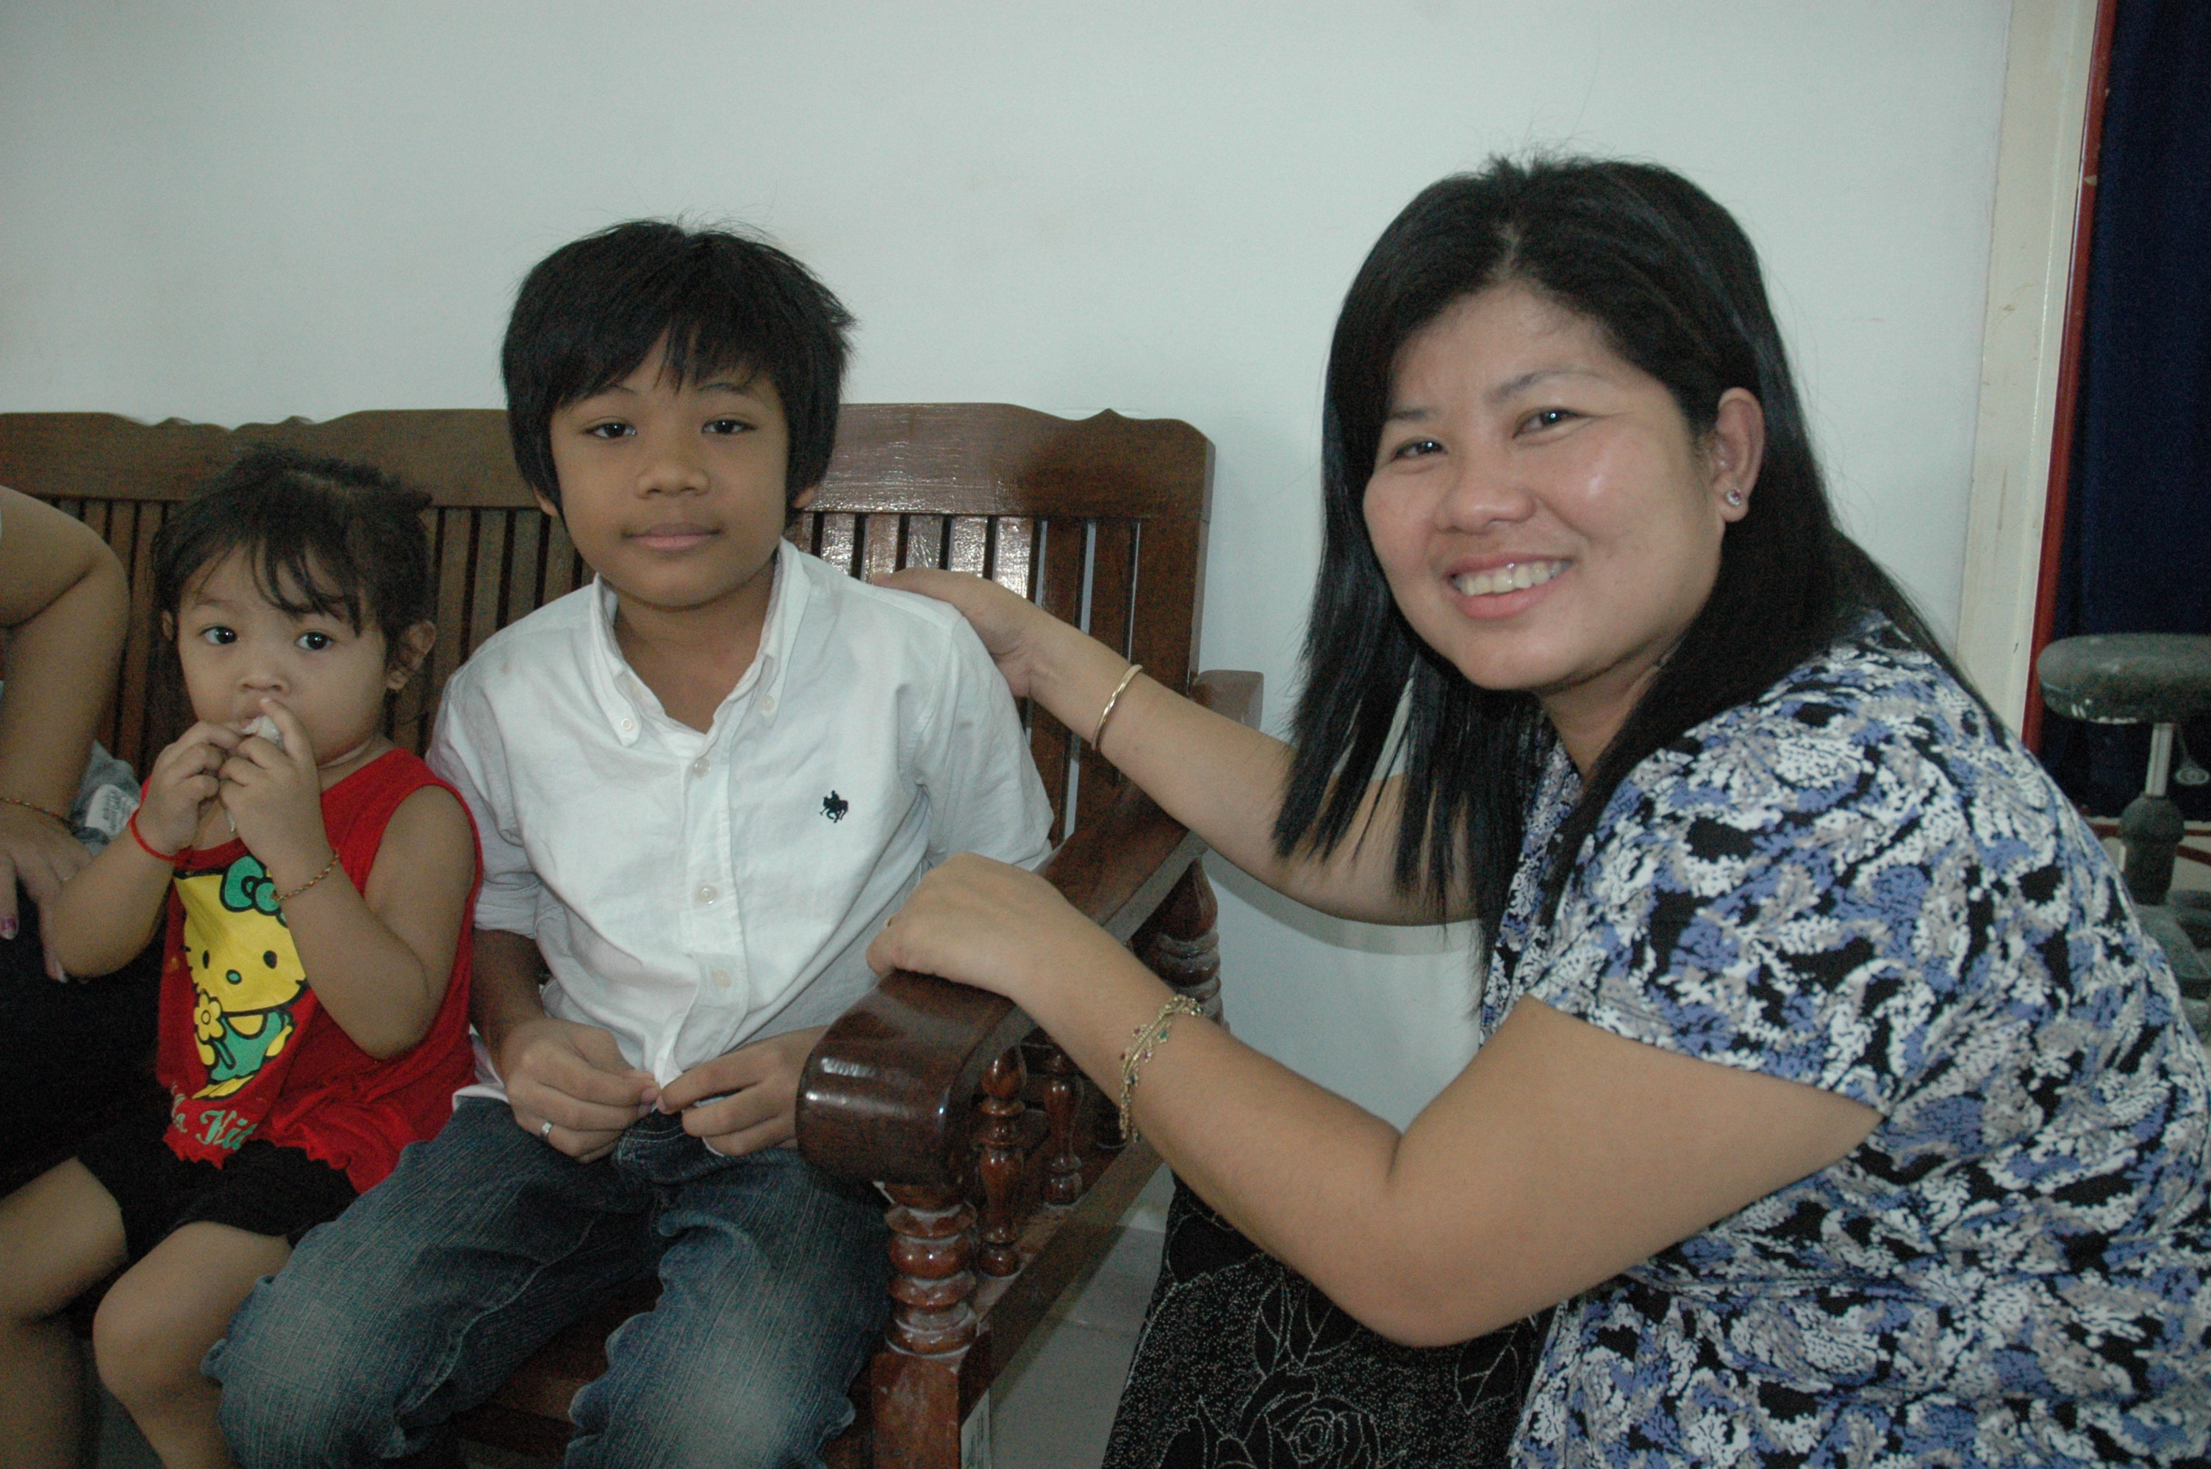
In 2010, I described a visit to The Foundation for the Welfare of the Crippled in Nonthaburi, Thailand. While the role of that institution is quite different from the work of the Cambodia Trust and the Cambodian School of Prosthetics and Orthotics, both are playing important roles not just in aiding people with disabilities to secure greater quality of life, but in creating greater understanding of the experience of disability. Both are creating history in their own distinct ways. Disability history that is taking shape beyond the western world and to which, perhaps, we need to pay more attention.
1
Images
- Sisary Kheng chats to a young outpatient while he awaits his consultation.
- Students attend a theory class.
- Developing skills in the workshops.
- Vina strives for some economic independence at his computer.
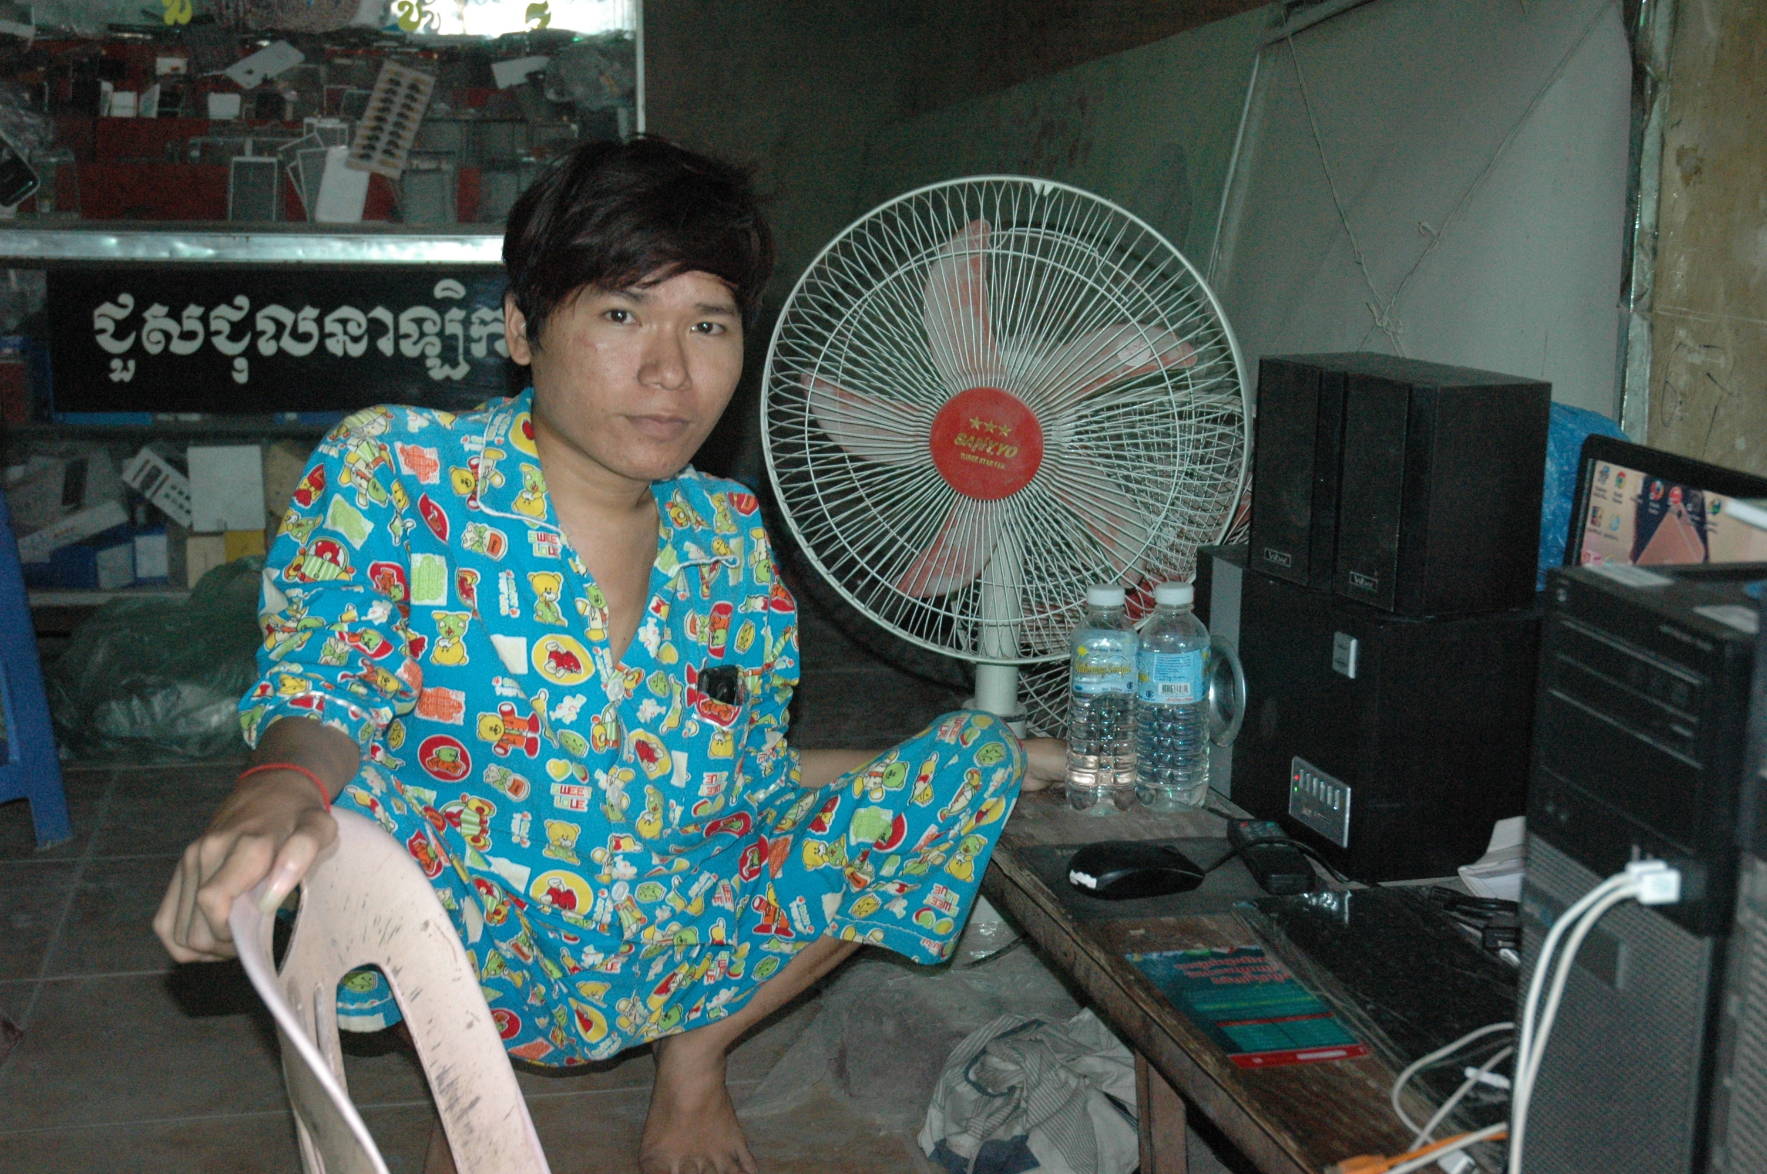
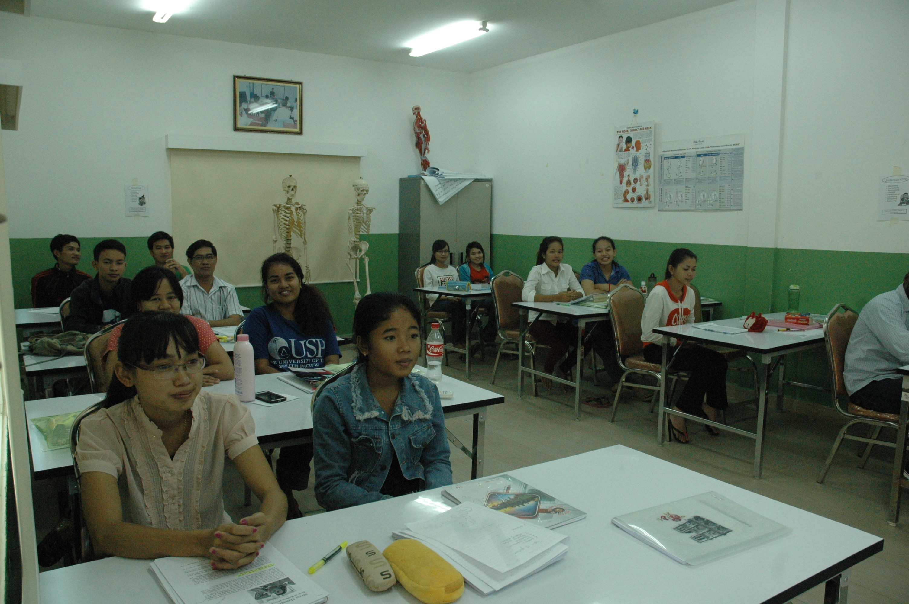
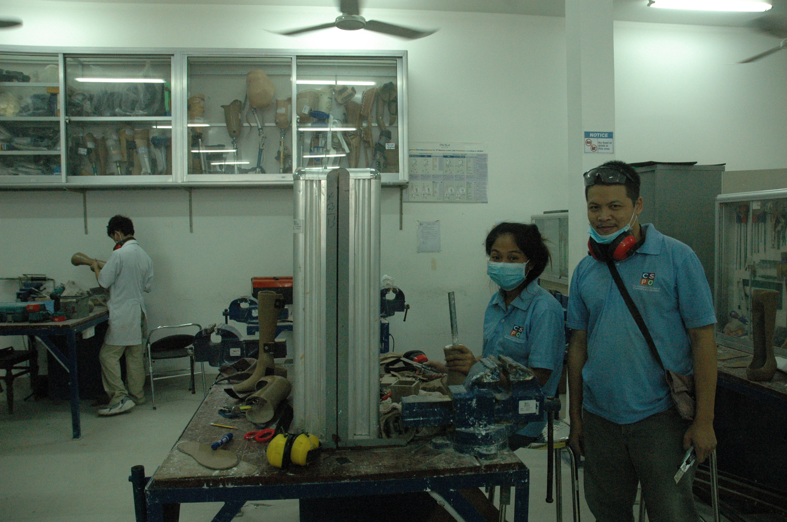
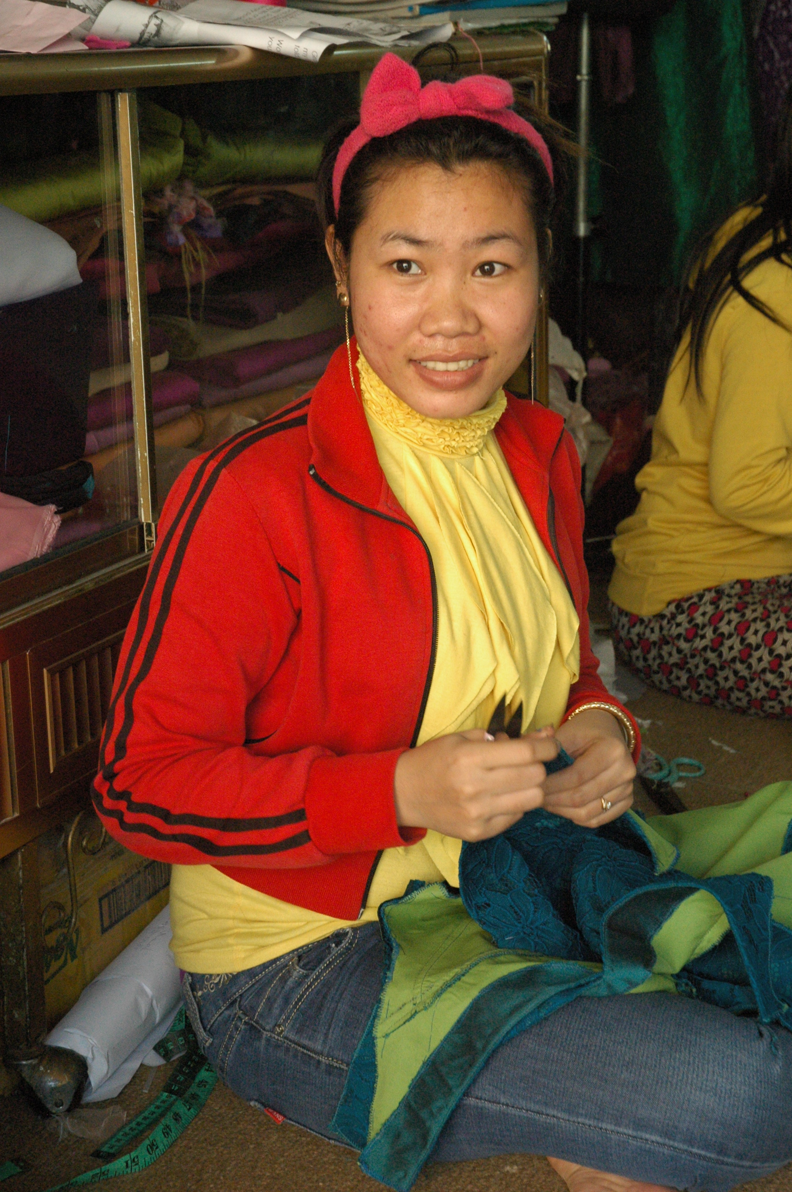
- Ath is training in dress design.
2
3
4
5

