FALL 2011 DHA NEWSLETTER
© Disability History Association

2 MESSAGE FROM THE PRESIDENT
(Penny Richards)

3 ANNOUNCEMENTS

6 UPCOMING CONFERENCES

8 CONFERENCE REPORT: The (Im)perfect Body on Display: Disability Studies at a National Popular Culture Conference
(Simone Diender)

10 CONFERENCE REPORT: “Ashes, Magma and Eruptions: Historicising Disability in Iceland”
(Pieter Verstraete and Jan Grue)

18 NEWS: Disability and Industrial Society project results in million pound award for Swansea University
(news release, sent by Anne Borsay)

20 PHOTOGRAPH
(Penny Richards)

MESSAGE FROM THE PRESIDENT
Penny L. Richards

 Welcome!

Don’t forget to renew your DHA membership for 2012!

Now that I’ve assembled a few of these newsletters, I’m seeing a pattern: I sit down and think, well, I don’t have much material really... hope I can find enough to make a respectable newsletter. But then I look at what the association is up to (like our new publications award, and the conference we’re co-sponsoring in Geneva, Switzerland, next year), and I look at what other folks are up to, and what conferences are welcoming disability history scholarship.... and before I know it, we have twenty pages. Which is true again this time. The field of disability history is vibrant, and growing! So...

Don’t forget to renew your DHA membership for 2012!

On the last page, I’ve included a photograph taken at a memorial reception for Paul Longmore, at Occidental College in Los Angeles, on October 3. Paul was an undergraduate and masters’ student in history at Oxy, and the history department hosted a lovely gathering. Cathy Kudlick gave the main talk (based on her item in our spring newsletter), and many others contributed shorter remembrances, including disability scholars like Phil Ferguson and Victoria Lewis, and longtime friends like Rev. Rex McDaniel (one of Paul’s college roommates) and Paul’s advisor, Professor Norman Cohen. Here’s the Occidental College news item about the reception:
http://www.oxy.edu/x11815.xml

Don’t forget to renew your DHA membership for 2012!
DHA ANNOUNCEMENTS

********NEW: DHA Publication Awards**********
The Disability History Association is excited to announce a new Outstanding Book/Article Award. Submissions are welcome from scholars in all fields who engage in work relating to the history of disability. The award will alternate between books and peer-reviewed articles. The award committee will accept book submissions in even years beginning in 2012 and article submissions in odd years beginning in 2013.

Although the award is open to all authors covering all geographic areas and time periods, the publication must be in English*, and must have a publication date within the two years preceding the submission date (ie, 2010-2012 for books eligible in the first award cycle, and 2011-2013 for articles submitted during the 2013 award cycle).

Book submission may be single- or multiple-authored and may be a single monograph or an edited collection, provided the latter contains new and original scholarship. Articles may also be single- or multiple-authored and must be published in a peer-reviewed academic journal.

The amount of the award is $600 for the book award and $400 for the article award.

All submissions should be sent to the award committee no later than May 1. Authors should arrange for four (4) copies of the book or article to be mailed directly to the award committee. Submissions may be sent electronically in a format compatible with screen reading software, such as a .doc file or a text-based .pdf. Submissions may also be sent in hard copy.

The Disability History Association board will announce the recipient of the DHA Outstanding Book/Article Award in September.

*While this year’s call is for works in English, the DHA board is considering how we can expand the call in future, to include works in more languages. We’d welcome input from folks with experience in publication awards, who might have some practical ideas for us.

DHA Graduate Student Travel Scholarships awarded
Two graduate students received funding from the DHA’s Graduate Student Travel Scholarships, intended to support graduate students who will be participating in disability history sessions at scholarly conferences. Simone Diender’s award supported her attendance at the Popular Culture Association/American Culture Association (PCA/ACA) meeting last April, in San Antonio TX. Jaipreet Virdi was the other recipient; Virdi used the award to present her doctoral work on deaf resistance to surgical interventions in the early 19th century, at the “Disability and the Victorians” conference in Leeds (UK) next summer. Both students are expected to share their conference experiences in the DHA newsletter; Diender’s report is in this issue (see p. 7).

BRIEF ITEMS:

News of a new journal, from Pieter Verstraete:
“A new journal just has been born: the first issue of Ethnographica Journal on Culture and Disability just recently appeared on the world wide web! Ethnographica is an open access journal that is available through the website of the Culture and Disability International Network (CADIN). Please have a look at http://soc.kuleuven.be/werkdocumenten/ojs/index.php/eerstejournal for direct access to the first articles and if you would consider to submit a manuscript please do contact patrick.devlieger@soc.kuleuven.be
or jori.decoster@soc.kuleuven.be”

Lecture Series on Disability History, London
The Institute of Historical Research in London will host several lectures on disability history this academic year, including Anne Borsay (7 November), Wendy Gagen (5 December), Vicky Long (6 February), Ann Roberts (5 March), and Simon Jarrett and Rosie Sherrington (2 April). See he full announcement for lecture topics, locations, and times:
http://www.history.ac.uk/events/seminars/328

PBS to air “Life’s Worth Living” on 27 October 2011
By the time this newsletter goes out, a documentary about American disability rights activist Fred Fay (1944-2011) will have aired on most PBS stations, as part of the series “Independent Lens,” and it should be available for purchase. The trailer is online here:
http://www.youtube.com/watch?v=CGbcAHEUOPI

Bess Williamson featured on podcast
The most recent edition of the Inventive Voices podcast, produced by the Lemelson Center for the Study of Invention and Innovation, features disability historian Bess Williamson, talking about universal design and kitchen gadgets:
http://blog.americanhistory.si.edu/osaycanyousee/2011/05/podcast-whats-universal-about-universal-design.html

Family history and disability at the National Archives
The tumblr “I Found it in the National Archives” recently featured an item about a family history find: an American family learned more about a disabled uncle who was turned away from Ellis Island, from the record of his 1906 deportation hearing. “My grandmother testified at the hearing, showed her bankbook, and swore she would support her handicapped brother,” writes Wendy Griswold. “My grandmother’s congressman sent a letter of support. Wolf was nevertheless deemed likely to become a public charge and was sent directly back to Europe.” Read the whole story here:
http://usnatarchivesfoundit.tumblr.com/post/7499464939/wendy-griswold

The Accessible Museum in 1913--new photos at Flickr Commons
The Tyne & Wear Archives and Museums recently uploaded a set of 38 striking images (with no-known-copyright status) to Flickr Commons, all of them depicting a 1913 experiment conducted by British museum curator J. A. Charlton Deas. Deas arranged for blind schoolchildren and adults to handle the Sunderland Museum’s eclectic holdings, including armor, zoological specimens, skeletons, paintings, sculptures, weapons, and vases. Attendees were also offered spoken-word captions presented by docents, and lectures by local experts. The photo set, “‘Seeing’ through Touch,” is at this link:
http://www.flickr.com/photos/twm_news/sets/72157626903151525/
UPCOMING CONFERENCES

3-4 December 2011
Economies of Disease & Disability from Antiquity to the Middle Ages is an interdisciplinary workshop to be held at the University of Nottingham (UK). The deadline for submissions has passed; watch the website for program details.
http://disease.nottingham.ac.uk/doku.php

22-23 March 2012
Disability Law Symposium at Boalt Hall, UC-Berkeley, around the theme “Rebranding Disability Law: The Intersection of Disability with Gender, Race, Class, and Other Identities.” Abstracts due 16 November 2011. More information:
http://berkeleydisabilityrights.tumblr.com/

22-23 March 2012
Cripples, Idiots, Lepers and Freaks: Extraordinary Bodies/Extraordinary Minds is an interdisciplinary conference to be held at the Graduate Center of the City University of New York. Rosemarie Garland-Thomson will present the Keynote Address on 23 March. Deadline for abstracts is 5 December 2011: More information:
http://esaconference2012.wordpress.com/

26-27 March 2012
Pacific Rim International Conference on Disability and Diversity will be held at the Hawaii Convention Center in Honolulu, with the theme “Living to our Complete Potential.” Final submission deadline is 16 December 2011. More information about this conference:
http://www.pacrim.hawaii.edu/

10-13 May 2012
International Congress on Medieval Studies will be held at Western Michigan University in Kalamazoo. This major conference of medievalists will feature a session on “Intellectual Disability in Medieval and Early Modern Europe.” For more information about the congress:
http://www.wmich.edu/medieval/congress/

30 May-1 June 2012
Canadian Disability Studies Association will hold its ninth annual conference hosted by Wilfred Laurier University and the University of Waterloo, in conjunction with the Congress of the Canadian Federation of the Humanities and Social Sciences. More information:
http://www.cdsa-acei.ca/conference.html

15-16 June 2012
Sensualizing Deformity: Communication and Construction of Monstrous Embodiment will be a two-day interdisciplinary conference at the University of Edinburgh (UK). 31 January 2012 is the deadline for submitting abstracts.
http://sensualisingdeformity.blogspot.com/p/call-for-papers.html

20-23 June 2012
Society for Disability Studies will hold its 25th annual conference in Denver, Colorado, with the theme “Collaborations, Cultures, and Communities.” Deadline for submissions is 1 December 2011. More information here:
http://disstudies.org/annual-conference/2012cfp/

27-30 June 2012
Internationalization in Education (18th-20th centuries) is a joint conference of the International Standing Conference for the History of Education, the Society for the History of Children and Youth, and the Disability History Association (yes, that’s us), to be held in Geneva, Switzerland. The deadline for submissions has been extended to 30 November 2011. More information at the conference website:
http://cms2.unige.ch/ische34-shcy-dha/crbst_2.html

24-29 July 2012
8th Deaf History International Conference will be held in Toronto, Canada, hosted by the Canadian Cultural Society of the Deaf, with the theme “Telling Deaf Lives: Biographies and Autobiographies.” The deadline for submitting abstracts has passed. Watch the website for the program when available:
http://www.dhiconference2012.ca/english/call_papers.html

30 July-1 August 2012
Disability & the Victorians: Confronting Legacies will be held at the Leeds (UK) Centre for Victorian Studies, at Leeds Trinity University College. The deadline for proposals has passed. More information about the conference at the website:
http://www.leedstrinity.ac.uk/departments/history/victorian_studies/conference/Pages/DisabilityandtheVictorians.aspx

23-26 August 2012
Passages from Antiquity to the Middle Ages: Infirmitas, Social and Cultural Approaches to Cure, Caring and Health will be held at the University of Tampere, Finland, and welcomes papers that focus on the social and cultural contexts of illness and care. The deadline for submissions has passed.
http://www.uta.fi/trivium/passages/passages5.html

10-12 September 2012
Society for the Social History of Medicine will hold its biannual, international, interdisciplinary meeting at the University of London, with the topic “Emotions, Health, and Wellbeing.” Deadline for submitting proposals is 16 January 2012.
http://medicalhumanities.wordpress.com/2011/09/08/emotions-health-and-wellbeing-conference/

CONFERENCE REPORT:
The (Im)perfect Body on Display:
Disability Studies at a National Popular Culture Conference

Simone Diender

The joint conference of the Popular Culture Association and the American Culture Association (PCA/ACA) is a huge happening. Its yearly national meeting draws about 3000 presenters from all over the United States. In addition, hundreds of scholars discuss popular culture at the organization’s regional meetings. While students of disability history may not immediately think about popular culture as an area for relevant scholarship, the PCA/ACA conference drew me, a fourth-year graduate student in American History, because of its expertise concerning the power of representation. Among the hundreds of panels, many consider the influence of mass media and popular culture on American politics, social life, and the rights of minorities. The rights of the disabled are receiving more attention at every meeting.

The PCA/ACA conference I attended took place from April 21 to 23, 2011, in San Antonio TX. I visited the meeting to present a paper about the eugenics movement in the decade before World War II and to get to know other scholars working in the field of disability studies. As my own paper dealt with marketing and pr strategies of American eugenicists, I was especially interested in popular culture sources on the display of the (imperfect) body in modern society.

My paper, “American Citizen, Responsible Parent: Eugenics Propaganda for the American Bedroom, 1936-1942” was part of the panel “Responses to Physical and Mental Difference” in the conference’s American History and Culture division. Exchanging ideas with my fellow panelists was very fruitful. One of them, Deborah Marinski of Ohio University, had written about the architecture of mental institutions in the nineteenth century. While showing illustrations of the buildings, she explained how new designs revealed changing ideas about the treatment of the mentally ill, from a policy of inclusion into American society rather than separation from it. Another panelist, Lindsay Patterson of Ohio State University, discussed the struggle by physically disabled students to gain access to university campus buildings in the 1960s and 1970s. Depictions of both the campus architecture and the students’ political pamphlets illustrated how important the imagery of physical difference is for the advancement of disability rights.

The members of my panel came from different parts of the country and from different sub-disciplinary backgrounds. At no other meeting would I have talked about the representation of otherness with scholars of nineteenth-century or architecture history. Yet, the way they and I framed our arguments about the power of imagery was very similar and gave each of us new insights in the study of our subjects.

Beside my own panel I attended presentations in the areas of “Medical Humanities: Health, Disease & Culture,” “The Body & Physical Difference,” and “Fat Studies.” The latter is a particularly dynamic field of study because it deals explicitly with the perception of the unhealthy body. Not all academics agree about the use of interdisciplinary research of obesity in its own right, but representatives of Fat Studies argue that their position is similar to those of women’s, African American, and disability studies scholars in the past. I am interested to hear from others in the community of disability historians whether they consider obesity a part of their own field, and if not, whether they consider it a meritable field of its own.

Overall, the PCA/ACA meeting introduced me to many different sources for the study of disability and its representation in American history. It also inspired me to use popular culture materials in my own disability history course for undergraduates. Mass media and especially popular images of people with mental and physical disabilities offer students concrete topics to discuss and are closer to their own daily surroundings than scholarly articles or works by disability rights activists. Based on my own experiences at the conference, I expect students to learn how prevalent the negative image of the imperfect body is in everything we encounter in our daily media consumption. Therefore, I can recommend the PCA/ACA conference for all interested in the cutting edge of disability studies. Its sheer size and inclusiveness of topics makes the meeting relevant for all of those interested in the representation of otherness and bodily (im)perfectness.

[Editor’s note: Simone Diender was recipient of a DHA Graduate Student Travel Scholarship to attend the PCA/ACA meeting.]
CONFERENCE REPORT:
Ashes, Magma and Eruptions: Historicising Disability in Iceland

Pieter Verstraete & Jan Grue

From Friday May 27th until Saturday May 28th 2011 Iceland hosted the 11th research conference of the Nordic Network on Disability Research (NNDR). Although the eruption of Grimsvöttn vulcano made it quiet unclear whether the conference actually would take place, the conference opened as planned on Friday morning. The ash cloud which had prevented many airplanes earlier that week to land on Reykjavik’s airport had disappeared into the direction of the Baltic states. Very soon after being opened by Rannveig Traustadottir, Guomundur Magnusson & Borgunn Ytterhus it became clear that, although the volcanic activity of Grimsvöttn had stopped, a lot of its energy had been captured by the attendants, something which very easily could lead to the eruption of that recently discovered volcano named ‘disability.’

Throughout the two-day Nordic conference disability once more showed its capability of disturbing well-established worlds, self-evident convictions and taken for granted beliefs. Scholars coming from all around the world exposed the effects of anti-discriminatory laws in the Nordic countries, pointed towards the consequences of community based practices, focuses on how new technologies affected the lives of persons with disabilities, questioned the role of art in professional contexts, considered and extended the plea for personal assistance measures and … showed that disability history during the past two decades not only has established itself as an important and attractive field of study for disability scholars, but also has the distortive potential to “reconsider virtually every concept taken for granted.” In this short conference report we first of all would like to give a summary overview of some of the NNDR presentations and keynote lectures which were related to the history of disability and disability theory. Secondly, we would like to indicate some of histories’ potentialities for elaborating disability theory and finally, we want to pinpoint one or two shortcomings of the current state of disability history.

The magmatic force of disability history

After arriving on Icelandic grounds one has to board a bus which takes you from Kevlakik airport to the center of Reykjavik. A ride which only takes approximately 45 minutes but seems to catapult you irresistibly back in time for besides rocks, lava and moss there is not much to see. It’s like riding through a no man’s land where the only thing that reminds you of the existence of human beings is the road itself. One might very well put this desolate landscape on a par with how many professionals, politicians, ordinary folks and administrators still today tend to think about disability: something which is quiet inhospitable, prevents one from leading a smooth and productive life, is a stable or fixed condition and remains the same forever.

This way of looking at disability and persons with disability of course does not take into account what causes the evaporation of steam, leads to enormous geysers sometimes reaching up till 15 meters high or results in the breathtaking beauty of warm and blue lagoons which all of a sudden can disrupt the monotonous green/brown color of the Icelandic landscape – at least the one between Reykjavik Centre and Kevlavik airport. By only focusing on a small portion of the surface one thus easily dismisses so to say the energetic explosions, the impredictable activity and the stunning beauty the Icelandic landscape is capable of. Although metaphors of course always can be criticized for not being capable of exactly representing what one is trying to say, the volcanic activity of the Icelandic landscape comes very close to the subject of the NNDR-conference, namely disability studies and disability history in particular.

The potentiality of (disability) history might very well be described by recalling the presentation held by the last keynote speaker of the NNDR-conference, namely Freyja Haraldsdottir, an Icelandic disability activist. Haraldsdottir opened her talk “Activism and disability research: The importance of a strong identity” by referring to the well-known words Martin Luther King spoke on August 23, 1963: “I have a dream that one day this nation will rise up and live out the true meaning of its creed. We hold these truths to be self-evident, that all men are created equal.” As for many other persons with disabilities living across the globe also for Haraldsdottir Luther’s message today very easily can be applied to the life-circumstance of persons with disabilities. It was only after having written an essay on Martin Luther King’s life that Haraldsdottir not only stopped skipping history classes, but also started her quest for independent living: “Before that I hated history,” Haraldsdottir stated before the audience, “I could not possibly gather why on earth one would be interested in history. Until I had to write the essay I did not understand the value of history. What was done, was done. From that time on I did not failed to attend a history class.” For Haraldsdottir history undoubtedly became associated with an activist attitude which led her to fight unceasingly for the application of personal assistance budget. At a certain moment in her presentation she gave a wonderful description of the effect these budgets have on persons with disabilities: “After having received this personal assistance budget,” she told the intrigued audience, “I suddenly was my parents’ daughter, my brothers’ sister and my friends’ friend.” By focusing on her own life history, Haraldsdottir made it very clear that the study of disability history for many disability historians/scholars inextricably is bound up to a politicized attitude.

From eugenics to ‘newgenics’

One of the sessions hosted by the Nordic Network on Disability Research conference which directly touched upon disability history was entitled ‘From eugenics to newgenics: Women with disabilities and reproductive control’ and sought to “explore how women with disabilities’ reproductive access to information, their range of reproductive choices and freedoms, and their ability to engage in autonomous sexual lives continue to be limited in modernity.” In particular the different contributors to this session aimed at highlighting and understanding the fact that throughout the twentieth century in the UK, Iceland and Canada women with intellectual disabilities continuously ran the risk of being subjected to (in)voluntary sterilization. What became clear was that the eugenic atmosphere which reigned in many Western countries at the turn of the nineteenth century also resulted in contested practices with regard to women with disabilities: Practices which differed from nation to nation, practices which had a huge and ever-lasting impact on the self-representations of women with disabilities themselves and practices whose consequences might be coped with by including the voices of “the other” in the process of turning that black page in our history.

In their contribution to the panel “‘I made the decision as a mother and that was it’: Exploring parents’ perspectives on reproductive choice and control for their daughters with intellectual disabilities” Tilley and Walmsley made clear that although the question of sterilization of women with intellectual disabilities was heavily debated in the 20’s and 30’s of the previous century in the UK compulsory sterilization was never made legal. As a matter of fact there was a strong anti-sterilization lobby which emphasized that the formalization of sterilization might (1) be interpreted as the acceptance and promotion of promiscuity and (2) lead to the release of many women with intellectual disabilities into society. Despite the absence of a legal framework, according to Tilley and Walmsley, English women with intellectual disabilities have been sterilized throughout the twentieth century. From the evidence both authors collected it became clear that the sterilization process often took place outside of the institution and many times was instigated by parents themselves. Anxious about the fact that they would have to raise the child after it was being born parents sometimes decided to perform sterilization in the best interest of the child and themselves.

In her lecture “Undermining disabled mothers through public policy in Canada and the UK” Malacrida pointed out that in contrast to the UK in Canada sterilization was formalized and could legally be conducted between 1928 – the foundation of the Eugenic Acts – and 1972 resulting in the sterilization of approximately 3000 known cases of women with intellectual disabilities. On the basis of interviews with 39 UK and 42 Canadian women she moreover poignantly described how the motherhood of women with intellectual disabilities frequently was challenged and questioned by what in a particular society was considered a ‘good mother.’ In one particular case for example a women with disabilities was told that she neglected her child. The reason for the removal of the child then was the fact that the mother had failed to buy lice shampoo. Taken into account that the mother could not apply for additional income because due to her ‘condition’ she could not have dependent children and thus was obliged to wait until the beginning of the next month this particular story shows how the motherhood of women with intellectual disabilities throughout history has been caught up within contemporary norms, vicious circles and self-fulfilling prophecies.

The most touching presentation, however, came from Hreinsdottir and Stefansdottir: “‘It shouldn’t be a secret’: Sterilisation of women with intellectual disabilities in Iceland.” Just like in Canada sterilization of people with intellectual disabilities also was legalized between 1938 and 1975. For that period 129 cases of involuntary sterilization have already been discovered, a number that probably underestimates reality. The far reaching consequences of forced sterilization were illustrated by the story of Ebba. Ebba Hreinsdottir was one of the 80 women with intellectual disabilities who became included in a life history project. Facing the audience of disability scholars she described the experience of her sterilization and how important the life histories session was for her in order to overcome the emotional impact of the surgical operation.

Ebba was 14 when the sterilization was conducted. However, it was only after becoming 27 and being confronted with other women in the institute who were being prepared for undergoing surgery that she discovered what really happened at that time: “It is very difficult to talk about the experience. It was like a burden for many years. Being able to talk about it freed myself.” The experience of sterilization was closely connected to her life in the institution were everything was decided for her. Actually the life history project re-established in a way her self-confidence and belief that she was able to relate to other and the surrounding world in her own way as becomes clear from the following quote: “This is so bad. I am not sure I would have wanted to have children but I would have liked to decide it myself. I hate it when others decide everything without asking me like they did at the institution.”

Crossing the Atlantic and enlarging culture

Ebba’s story abundantly made clear that the inclusion of disabled voices in the process of doing disability history not only – as recently has been argued by Atkinson and Walmsley – will result in a more detailed picture of our past but also positively contributes to the way persons with disabilities deal with their personal background and history. Besides this inclusionary approach towards disability history two more challenges for Twentieth-First disability historians were identified on the past Nordic Network on Disability Research Conference: First of all, disability historians will have to take into account that local disability history itself (increasingly) is influenced by international trends and events. And secondly, that there is a pressing need for more detailed disability histories primarily focussing on non-Western worlds.

The first challenge was illustrated by the keynote lecture of the respected American disability scholar Steven J. Taylor. In his presentation “The repeated cycle of exposés and reforms of institutions in the United States” Taylor reminded the international gathered audience of the different phases of exposure that the (American) asylum system had undergone throughout the twentieth century. By means of two famous quotes – one dating from the second half of the nineteenth century and the second from the beginning of the twentieth century – Taylor emphasized the grim life-circumstances of many disabled inmates who had to live in what Erving Goffman has described as ‘total asylums’:

Dorothea Dix – 1843 – “I proceed gentlemen, briefly to call to your attention the present states of insane persons confines within this commonwealth in cages, closets, cellars, stalls, pens! Chained, naked, beaten with rods and lashed into obedience.”

Clifford Beers – 1908 – "Why cannot a book be written which will free the helpless slaves of all creeds and colors contained in the asylums and sanitariums throughout the world? That is, free them from unnecessary abuses to which they are now subjected."

Although the conclusion Taylor draws from these and other examples tends to correspond with a rather simplified image of the institute as a historical factor in the history of disability – e.g., one only has to think about the fact that the institutes for the deaf triggered deaf activism in order to get a more complex description of the role played by institutions in disability history – his example of American institutional reforms after the Second World War makes clear that disability historians while describing local evolutions and events have to take into account the international context. During the Second World War, Taylor pointed out, so-called conscientious objectors – American men who did not want to go to Europe and fight Nazi-Germany – were being send to institutions for mentally ill patients due to the fact that many men belonging to the regular staff had chosen to cross the Atlantic. These pacifists exposed in very divergent ways the dehumanizing life-circumstances that ruled in the contemporary institutions and e.g. wrote newspaper articles entitled “mental patients here beaten and shackled,” took mentally ill patients out for a walk or for the first time brought a radio within the walls of the institute. Patterns like the one described here, where a conflict on the European continent influences the institutional reforms taken place in USA in the late 40’s, show how the care for and representations of persons with disabilities are undeniably influenced by events on an international level.

One thus very well could state that whereas Eva Simonsen recently has described disability history rightly as an international field of study one also has to add the international nature of disability history itself. Would it be exaggerated then to use the following description: There is no border where disability history artificially can be stopped. Those ideas, theoretical reflections, norms, cultural values and popular beliefs which influence the way disability is constructed do not abandon their inherent forces at the frontier of this or that country. Therefore it’s important that we do not only focus on the transmittance of corpuses of knowledge in between Western countries, but also examine how cultural approaches in history have merged and led to the coming into being of new ways of representing persons with disabilities.

This is of course not to say that for the time being the concept ‘culture’ would be completely absent in contemporary disability history. It’s just that up till this moment disability historians who have an interest in (disability) culture have tended to focus on Western contexts. It’s very difficult to find disability histories focusing on non-Western cultural contexts. To give just one example before jumping again to the Nordic Network Disability Research conference one could refer to the fact that although in Belgium the history of disability to a large extent is being written it is impossible to find a study that deals with the history of disability in a Belgian (post-)colonial context.

This lack of historical insight into the divergent ways disability as a concept and lived reality was respectively constructed and experienced in non-Western cultures – and the way these historical patterns have influenced our Western ideas with regard to difference and otherness – was displayed in the only session on the previous NNDR-conference that dealt with “Culture & society.” Although all of the three presenters in this session scholarly dealt with the cultural approach of disability and e.g. showed how attitudes towards disability in the Israeli society were shaped (Yoav Bergman) or how social and cultural factors currently influence the lives of disabled people in Trinidad and Tobago (Yansie Rolston) the discussion held afterwards made it clear that in order to get a better grip on the cultural understandings of disability one has to turn towards the underlying historical patterns which made the current situation possible. What, for example, exactly was the influence of the English mandate shortly after World War Two on the establishment of Israeli care system for persons with disabilities and what were the consequences of the melting cultural pot for the professional help given to persons with disabilities in Trinidad and Tobago?

Theoretical developments

Besides the emphasis on oral history, the need for paying attention to the global nature of the history of disability and the need for more than only Western approaches the past NNDR also made clear that many scholars are looking forward to welcoming new kinds of theoretical approaches of disability in general and disability history in particular. Up till now disability theory was characterized by the radically opposed medical and social(-constructivists) model. Although in recent years also the cultural model has come to the fore most of the time disability historians do tend to use and support the social model. The session “Theoretical perspectives” chaired by Dan Goodley, however, showed that a lot is going on on the level of disability theory. The first thing being that the rigid separation between mutually exclusive theoretical perspectives on disability is breaking down, and the second one being that this development is triggered by an increasing interest in interdisciplinary and theoretically sophisticated work.

The second point was amply illustrated through presentations by Kathy Boxall and Ben Simmons, both of whom dealt with issues of epistemology and experience. Boxall, who scholarly posed the question “Is the intellectual dis/ability of the knower epistemologically significant?”, drew on feminist theory in order to undermine the notion of a normative, objective knower, and to emphasize the significance of a situated, grounded basis in any epistemological position. Simmons, while exploring the life worlds of children with profound and multiple learning difficulties, championed a phenomenological approach based on the work of Maurice Merleau-Ponty as a strategy for overcoming the reductive descriptive techniques that are common in much of educational and social work. By turning themselves to phenomenology and feminism both authors emphasized the need for disability theory not to get stuck in self-evident theoretical frameworks. Instead of being seduced by theoretical stability Boxall and Simons presentations pointed towards a continuous quest for new and disturbing frameworks.

This plea also could be encountered in the presentation of Norwegian scholar Jan Grue: “The social model ‘versus’ the medical model: A discourse perspective.” Based on his examination of several Norwegian NGO’s working with and for persons with disabilities Grue argued that it was impossible to stick to the radical separation of the social and the medical model for whereas many official documents stated that the NGO’s at stake worked on the basis of the social model in practice many times professionals continued to use a medical approach. Moreover Grue argued that any dichotomous representation of a choice between a comprehensive social model, cultural model or medical model is at this point in time both false and counterproductive. In Grue’s own words: “there is a strong possibility that the medical model is being subsumed by other models.”

To conclude

The plea for new and innovative theoretical frameworks which was made by almost all of the presenters in this “Theoretical perspectives” session on disability theory triggered a discussion afterwards during which Jan Walmsley expressed her fear that disability theory would be less connected to the search for and realization of social change. The resulting question, namely ‘how can academia still be connected with the highly politicized agenda of the disability movement while at the same time finding new and refreshing theoretical perspectives,’ according to us shows how this past NNDR-conference not only has contributed largely to the state of the art with regard to disability history but also paved a way for scholars who are interested in working on the meta-theoretical assumptions of the existing disability histories. All of the disability history related presentations all in one way or another indeed showed that what is needed within disability history are innovative approaches which first of all take into account the global context which increasingly tends to shape the lives of persons with disabilities and secondly create new ways of thinking about social change, emancipatory forces and participatory strategies. Of course it’s not only the past which can help us in creating these innovative perspectives, but what lays behind or so to say beneath us might very well, just as the magmatic Icelandic underground, lead to unexpected eruptions of fertile lava which holds in itself the promise of a new though unknown time to come.

[Editor’s note: There is a set of photographs from the NNDR Conference in Reykjavík on Flickr, at this link:
http://www.flickr.com/photos/nndr/sets/72157627169180877/ ]
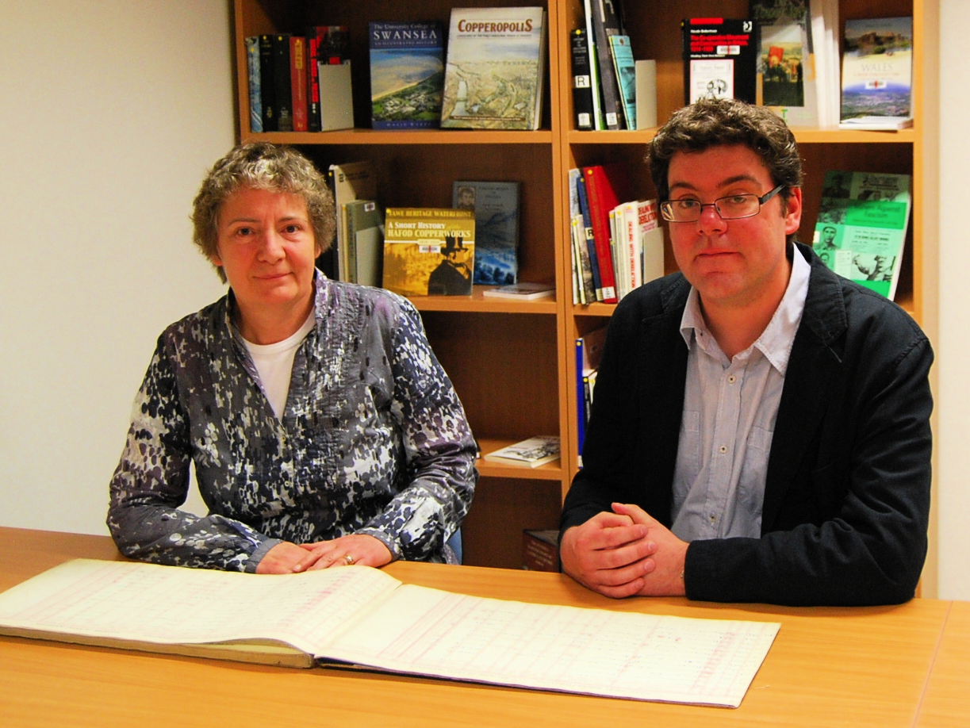
Photo: Professor Anne Borsay and Dr. David Turner examine coalfield records at the Richard Burton Archive.

Disability and Industrial Society project results in million pound award for Swansea University
(University press release, provided by Anne Borsay)
The Wellcome Trust has granted a Swansea University led research team almost one million pounds for a project which will explore the history of disability and industrialisation.
The research entitled ‘Disability and Industrial Society: A Comparative Cultural History of British Coalfields’ will bring together academics from Swansea, Aberystwyth, Northumbria and Strathclyde Universities to focus on how industrialization shaped perceptions and experiences of disability between 1780 and 1948.
The grant for £972,501, which will run from October 2011 to September 2016, makes Swansea the leading UK centre for disability history with a research programme of international significance.
The research team will be led by Professor Anne Borsay of the College of Human and Health Sciences whose book, Disability and Social Policy in Britain since 1750: A History of Exclusion (2005) has played a key role in developing disability history.

She will be supported by Dr David Turner of the University’s College of Arts and Humanities, who has recently held a prestigious Arts and Humanities Research Council Fellowship award for his work on disability in eighteenth-century England.

Four themes will be addressed by the team: the effects of economic and technological developments; the role of medical and welfare services; the consequences of politics, trade unionism and social relations; and the implications of these historical factors for the literary genre of coalfield narrative.
The project will produce a number of books and articles, as well as a web page of statistical data. The public engagement programme will ensure that the research findings are accessible to all, and will include a roadshow in south Wales in 2012, a workshop for health and social care professionals, and an exhibition on coalfield disability at the National Waterfront Museum in Swansea.
Professor Borsay said, “I am delighted to have this opportunity to progress the neglected field of disability history. The team is excited by the challenges of interdisciplinary, comparative research across three coalfields and looks forward to presenting the findings to a wide audience. We are grateful to the Wellcome Trust for their generous support.”
A disabled people’s panel will be convened eight times during the tenure of the award to ensure that the research and public engagement is informed by disabled people’s perspectives.
Dr Turner said, “For disabled people today, the project’s findings will challenge understandings of disability by demonstrating that attitudes and policies are socially constructed, and therefore open to change. The project will also contribute to current debates about welfare relief and ability to work by revealing the changing role of social, political and medical factors in determining eligibility for assistance.”
Rhian Davies, Chief Executive of Disability Wales said, “In history disabled people are most often characterised as the ‘deserving poor’. Disability Wales looks forward to participating in this timely research project which places disabled people at the centre of an unfolding story where disability and industrialisation are inextricably intertwined in ways which still resonate today”.
Three new posts will be funded at Swansea as a result of the project – two research fellow positions, and a PhD studentship. There will also be a research associate role created in each of the collaborating universities.

Dr Hywel Francis, MP for Aberavon, said, “This project is exciting for south Wales as it will look at a part of our coalmining history which has been previously neglected. Whilst coalmining communities in this region are renowned for their social solidarity it will be interesting to learn if disabilities caused as a result of working in this dangerous and unpredictable industry impacted on social unity, with what results and if this changes our understanding of our industrial past.”
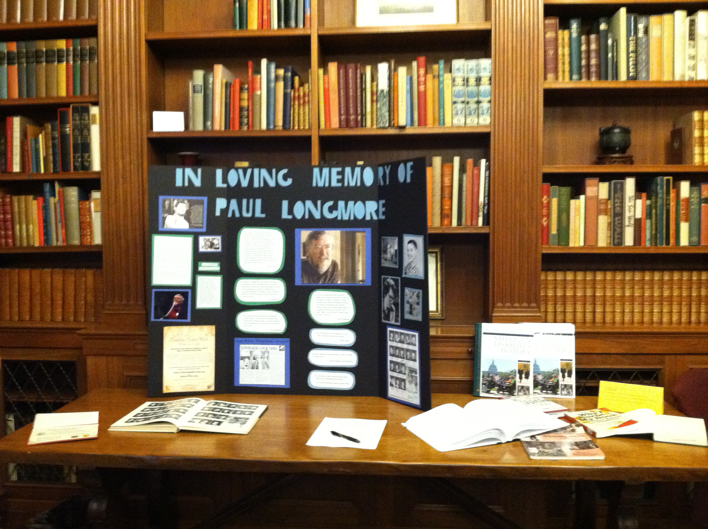

Above: A display at a memorial reception for Paul Longmore, held at Occidental College in Los Angeles on 3 October 2011. A trifold display board says “In Loving Memory of Paul Longmore” and has various photographs and quotes from Paul Longmore. On the table in front of the display, his Occidental College yearbook, a petition with a pen, three volumes of the Encyclopedia of Disability History, a copy of Why I Burned My Book, and several other books. Behind the display are library shelves and wood paneling. (Photograph by Penny Richards)

